Comparative efficacy of various exercise types and doses for depression in older adults: a systematic review of paired, network and dose-response meta-analyses

Appendix

Appendix 1: Search strategy 2
Appendix 2. Characteristics of included studies 4
Appendix 3. Risk of bias in the included studies 11
Appendix 4. methods 13
S4.1 Eligibility Criteria 13
S4.2 Data Coding and Management 13
S4.3 Statistical Analysis 14
Appendix 5. Pairwise analysis 16
S5.1 Details of pairwise meta-analyses 16
S5.2 Comparison-adjusted funnel plot of all studies 16
Appendix 6. Network meta- analysis 17
S6.1 network diagrams 17
S6.2 Table S3. Assessment of inconsistency within comparisons 17
S6.3 Dot splitting method to explore inconsistency 18
S6.4 Sensitivity analysis 19
S6.5 Network meta-regression 20
S6.6 GRADE Assessment 21
Appendix7. Dose network meta- analysis 22
S7.1 Table S7. Dataset 22
S7.2 Key assumptions of Network Meta-Analysis 26
S7.3 Models’ selection 29
S7.3 Dose-response relationships 34
S7.5 Predicted responses 35
S7.6 Ranking of effectiveness of interventions 36
References 37
Included studies 39
PRISMA NMA Checklist of Items to Include When Reporting A Systematic Review Involving a Network Meta-analysis 43

Appendix 1: Search strategy
Results | Search strategy | Database name/ Date of search
1470 | Search:  #1:"older"[Title/Abstract] OR "elderly"[Title/Abstract] OR "senior*"[Title/Abstract] OR "geriatric*"[Title/Abstract]  #2: "Exercise"[MeSH Terms] OR "Exergaming"[MeSH Terms] OR "Sports"[MeSH Terms] OR "Dancing"[MeSH Terms] OR "Yoga"[MeSH Terms] OR "Tai Ji"[MeSH Terms] OR "Qigong"[MeSH Terms] OR "Walking"[MeSH Terms] OR "Swimming"[MeSH Terms] OR "Exercise Movement Techniques"[MeSH Terms] OR "Physical Endurance"[MeSH Terms] OR "resistance" [MeSH Terms] OR "resistance*"[Title/Abstract]OR "exercise*"[Title/Abstract] OR "sport*"[Title/Abstract] OR "exergame*"[Title/Abstract] OR "physical activit*"[Title/Abstract] OR "training*"[Title/Abstract] OR "fitness*"[Title/Abstract] OR "cardio*"[Title/Abstract] OR "danc*"[Title/Abstract] OR "yoga"[Title/Abstract] OR "taichi"[Title/Abstract] OR "taiji"[Title/Abstract] OR "qigong"[Title/Abstract] OR "baduanjin"[Title/Abstract]OR "walk*"[Title/Abstract] OR "jog"[Title/Abstract] OR "run"[Title/Abstract] OR "swim*"[Title/Abstract] OR "cycl*"[Title/Abstract] OR "Pilates"[Title/Abstract] OR "physical endurance"[Title/Abstract]  #3: "Depressive Disorder"[MeSH Terms] OR "Depression"[MeSH Terms] OR "Mental Health"[MeSH Terms] OR "depress*"[Title/Abstract] OR "dysthymi*"[Title/Abstract] OR "Mental Health"[Title/Abstract] OR "mental disorder*"[Title/Abstract]  #4: "Randomized Controlled Trial"[Publication Type] OR "randomized controlled trial*"[Title/Abstract] OR "randomized clinical trial*"[Title/Abstract] OR "randomized controlled clinical trial*"[Title/Abstract] OR "rct"[Title/Abstract]  #5: #1AND #2 AND #3 AND #4 | PubMed  December, 2023
3541 | #1:TS=("older*" OR "elderly*" OR "senior*" OR "geriatric*")  #2:TS=(exercise* OR sport* OR physical activit* OR resistance* OR training* OR fitness* OR cardio* OR exergame* OR danc* OR yoga OR taichi OR taiji OR qigong OR baduanjin OR “wight Lifting” OR walk* OR jog* OR run* OR swim* OR danc* OR cycl* OR Pilates* OR "physical endurance")  #3:TS=(depress* OR dysthymi* OR “depressive disorder” OR “mental disorder*”)  #4:TS= ("randomized controlled trial*" or "randomized clinical trial*" or "Randomized controlled clinical trial*" or "RCT*")  #5: #1 AND #2 AND #3 AND #4 | Web of Science  December, 2023
2275 | #1:'older'/exp OR 'elderly':ti,kw,ab OR 'senior'/exp OR 'geriatric':ti,kw,ab  #2: 'exercise'/exp OR 'exercise*':ab,kw,ti OR 'sport'/exp OR 'sport*':ab,kw,ti OR 'exergame'/exp OR 'exergame*':ab,kw,ti OR 'physical activit*':ab,kw,ti OR 'training*':ab,kw,ti OR ' resistance*'/exp OR 'resistance*':ab,kw,ti OR 'fitness*':ab,kw,ti OR 'cardio*':ab,kw,ti OR 'dancing'/exp OR 'danc*':ab,kw,ti OR 'yoga'/exp OR 'yoga':ab,kw,ti OR 'tai chi'/exp OR 'taichi':ab,kw,ti OR 'taiji':ab,kw,ti OR 'qigong':ab,kw,ti OR 'baduanjin'/exp OR 'baduanjin':ab,kw,ti OR 'wight lifting':ab,kw,ti OR 'walking'/exp OR 'walk*':ab,kw,ti OR 'jog*':ab,kw,ti OR 'run*':ab,kw,ti OR 'swimming'/exp OR 'swim*':ab,kw,ti OR 'cycl*':ab,kw,ti  #3: 'depression'/exp OR 'depress*':ab,kw,ti OR 'dysthymi*':ab,kw,ti OR 'mental health':ab,kw,ti OR 'mental disorde':ab,kw,ti OR 'mood disorder':ab,kw,ti OR 'depressive disorder':ab,kw,ti  #4: 'randomized controlled trial'/exp OR 'randomized controlled trial*':ti,ab,kw OR 'randomized clinical trial*':ti,ab,kw OR 'randomized clinical trials*':kw,ab,ti OR 'randomized controlled clinical trial*':ab,kw,ti OR 'rct*':ab,ti,kw  #5: #1 AND #2 AND #3 AND #4 | EMBASE  December, 2023
340 | S1: tiab="older*" OR "elderly*" OR "senior*" OR "geriatric*"  S2: tiab =exercise* OR sport* OR exergame* OR "physical activit*" OR training* OR "fitness*" OR resistance*OR "cardio*" OR danc* OR yoga OR taichi OR taiji OR qigong OR baduanjin OR "wight Lifting" OR walk* OR jog OR run OR swim* OR cycl*  S3: tiab =depress* OR depress* OR “Mental Health” OR “Mental Disorder*” OR OR “Mood Disorder*” OR depressive disorder  S4: tiab ="randomized controlled trial*" or "randomized clinical trial*" or "Randomized controlled clinical trial*" or "RCT* "  S5: S1 AND S2 AND S3 AND S4 | PsycINFO  December, 2023
171 | S1: SU =("older*" OR "elderly*" OR "senior*" OR "geriatric*")  S2: SU =exercise* OR sport* OR exergame* OR "physical activit*" OR training* OR "fitness*" OR resistance* OR "cardio*" OR danc* OR yoga OR taichi OR taiji OR qigong OR baduanjin OR "wight Lifting" OR walk* OR jog OR run OR swim* OR cycl*  S3: SU =depress* OR depress* OR “Mental Health” OR “Mental Disorder*” OR OR “Mood Disorder*” OR depressive disorder  S4: SU ="randomized controlled trial*" or "randomized clinical trial*" or "Randomized controlled clinical trial*" or "RCT*"  S5: S1 AND S2 AND S3 AND S4 | CINAHL  December, 2023
1350 | TITLE-ABS-KEY ("older*" OR "elderly*" OR "senior*" OR "geriatric*" ) AND TITLE-ABS-KEY ( exercise* OR sport* OR exergame* OR "physical activit*" OR training* OR fitness* OR resistance* OR cardio* OR exergame* OR danc* OR yoga OR taichi OR taiji OR qigong OR baduanjin OR "wight Lifting" OR walk* OR jog* OR run* OR swim* OR danc* OR cycl* ) AND TITLE-ABS-KEY ( depress* OR dysthymi* OR "Mental Health" OR "Mental Disorder*" OR "Mood Disorder*" OR depressive disorder ) AND TITLE-ABS-KEY ( "randomized controlled trial*" OR "randomized clinical trial*" OR "Randomized controlled clinical trial*" OR "rct*" ) | Scopus  December, 2023
9147

Appendix 2. Characteristics of included studies
Table S1. Characteristics of included studies
Author | Sample size(n) | Intervention M_{age} (SD) | Control M_{age} (SD) | Intervention parameter | Intervention group condition | Control  group  condition | Outcome | Diagnosis | Country
Angeles (2016) (1) | 20 | 65.0 (3.3) | 69.3 (7.4) | Mixed | 12 weeks 3 days per week 50 min per session | Usual care | POMS-SF | No depression | Mexico
Ansai (2015) (2) | 46 | 82.8 (2.8) | 82.6 (2.6) | Resistance | 16 weeks 3 days per week 60 min per session | Usual care | GDS-15 | No depression | Brazil
Antunes (2005) (3) | 46 | 68.1 (5.5) | 65.9 (3.8) | Aerobic | 26 weeks 3 days per week 20-60 min per session | Wait-list | GDS-30 | No depression | Brazil
Baklouti(2023) (4) | 160 | ≥65.0 | ≥65.0 | Mind-body | 8 weeks 2 days per week 80 min per session | Attention control | DASS-21 | No depression | Tunis
Bernard (2015) (5) | 121 | 65.5 (4.0) | 65.5 (4.4) | Aerobic | 26 weeks 2 days per week 40 min per session | Wait-list | BDI-II | No depression | France
Bethany (2005) (6) | 42 | 83.1 (4.8) | 83.1 (4.8) | G1: Aerobic  G2: Mind-body | 6 weeks 3 days per week 30 min per session | Attention control | BDI-II | No depression | American
Blumenthal (1991) Females (7) | 49 | 67.8 (5.9) | 66.8 (4.3) | G1: Mixed  G2: Mind-body | 16 weeks 3 days per week 60 min per session | Wait-list | CESD-20 | No depression | American
Blumenthal (1991) males (7) | 48 | 66.5 (4.3) | 66.8 (4.3) | G1: Mixed  G2: Mind-body | 16 weeks 3 days per week 60 min per session | Wait-list | CESD-20 | No depression | American
Bonura (2014) (8) | 98 | 77.0 (7.3) | 77.0 (7.3) | G1: Mixed  G2: Mind-body | 6 weeks 1 days per week 45 min per session | Wait-list | GDS-30 | No depression | American
Bouaziz (2019) (9) | 56 | 72.9 (2.5) | 74.3 (3.4) | Aerobic | 9 weeks 2 days per week 30 min per session | Wait-list | GADS | No depression | France
Brenes (2007) (10) | 26 | 73.5 ± 7.8 | 73.9 ± 5.8 | Mixed | 16 weeks 3 days per week 60 min per session | Usual care | HAM-D | Depressive symptoms | American
Brown (2009) (11) | 46 | 81.5 (6.9) | 78.1 (6.4) | Mixed | 26 weeks 2 days per week 60 min per session | Usual care | GDS-30 | No depression | Australia
Chen (2009) (12) | 73 | 65.8 (4.3) | 72.4 (6.0) | Mind-body | 26 weeks 3 days per week 70 min per session | Wait-list | TDQ | No depression | China
Chen (2023) (13) | 28 | 76.8(4.8) | 76.8(4.8) | Resistance | 12 weeks 2 days per week 50 min per session | Wait-list | GDS-15 | No depression | American
Cheng (2012) (14) | 24 | 81.0 (7.7) | 82.5 (7.1) | Mind-body | 12 weeks 3 days per week 60 min per session | Attention control | GDS-15 | Depressive symptoms | China
Chin A Paw (2004) (15) | 76 | 81.0 (5.8) | 81.3 (4.4) | Resistance | 26 weeks  2 days per week  45-60 min per session | Attention control | GDS-30 | No depression | Netherlands
Choi (2018) (16) | 42 | 77.6 (5.69) | 78.8 (5.83) | Mind-body | 12 weeks  4 days per week  30-40 min per session | Wait-list | GDS-15 | Depressive symptoms | Korea
Chou(2004) (17) | 14 | 72.6 (4.2) | 72.6 (4.2) | Mind-body | 12 weeks  3 days per week  45 min per session | Wait-list | CESD-20 | MDD | China
Clegg (2014) (18) | 70 | 79.4 (7.9) | 78.0 (10.5) | Resistance | 12 weeks  15 days per week  15 min per session | Usual care | GDS-15 | No depression | England
Collier (1997) (19) | 38 | 71 (N/R) | 69 (N/R) | Resistance | 10 weeks  3 days per week  50 min per session | Usual care | GDS-30 | No depression | American
Conradsson (2010) (20) | 138 | 85.3 (6.1) | 84.2 (6.8) | Mixed | 13 weeks  2.5 days per week  45 min per session | Attention control | GDS-15 | Depressive symptoms | Sweden
Damush(1999) (21) | 62 | 68 (5.58) | 68 (5.58) | Resistance | 8 weeks  2 days per week  45 min per session | Waiting List | MHFI | Depressive symptoms | American
Dong (2013) (22) | 49 | 68.5 (N/R) | 68.5 (N/R) | Mind-body | 12 weeks  3 days per week  60 min per session | N/R | GDS-15 | Depressive symptoms | China
Emery (1990) (23) | 38 | 72 (6) | 72 (6) | Mixed | 12 weeks  3 days per week  60 min per session | Wait-list | CESD-20 | Depressive symptoms | American
Fakhari (2017) (24) | 56 | 69.2 (5.5) | 69.3 (5.0) | Mind-body | 12 weeks  3 days per week  20-25 min per session | Usual care | BDI-II | MDD | Iran
Favilla (1992) (25) | 64 | 73 (4.0) | 73 (4.0) | Resistance (high) | 6 weeks  3 days per week  60 min per session | Wait-list | GDS-30 | Depressive symptoms | American
Frye (2007) (26) | 44 | 69.2 (9.3) | 69.2 (9.3) | Mind-body | 12 weeks  3 days per week  60 min per session | Usual care | CESD-20 | Depressive symptoms | American
Ge (2021) (27) | 65 | 70.2(5.4) | 72.9(6.6) | Mind-body | 8 weeks  3 days per week  60 min per session | Usual care | GDS-30 | No depression | China
Gusi (2008) (28) | 106 | 71 (5) | 74 (6) | Aerobic | 26 weeks  3 days per week  50 min per session | Usual care | GDS-15 | No depression | Spain
Haboush (2006) (29) | 22 | 69.4 (5.4) | 69.4 (5.4) | Aerobic | 8 weeks  1 day per week  45 min per session | Wait-list | HRSD | MDD | American
Hars (2014) (30) | 134 | 75 (8) | 76 (6) | Aerobic | 26 weeks  1 day per week  60 min per session | Wait-list | HADS-D | No depression | Switzerland
Huang (2015) (31) | 39 | 76.4 | 75.9 | Mixed | 12 weeks  3 days per week  50 min per session | Usual care | GDS-15 | MDD | China
Irwin (2012) (32) | 111 | 70.7 (5.9) | 71.4 (7.7) | Mind-body | 16 weeks  3 days per week  40 min per session | Attention control | BDI-II | No depression | American
Irwin (2014) (33) | 73 | 66.3 (7.4) | 66.4 (7.7) | Mind-body | 17 weeks  1 day per week  120 min per session | Attention control | IDS-C | No depression | American
Karapınar (2022) (34) | 124 | 76.5 | 75 | Mixed | NA  5 days per week  40 min per session | Usual care | GDS-15 | Depressive symptoms | Turkey
Kekalaine (2018) (35) | 101 | 69.0 (3.3) | 68.3 (2.3) | Resistance (high) | 38 weeks  3 days per week  60 min per session | Usual care | BDI-II | No depression | Finland
Kerse (2010) (36) | 193 | 81.4(4.8) | 80.8(3.9) | Mixed | 26 weeks  3 days per week  30 min per session | Attention control | GDS-15 | No depression | New Zealand
Kim (2019) (37) | 21 | 76.1 (3.9) | 76.4 (3.3) | Resistance | 24 weeks  3 days per week  45 min per session | Usual care | GDS-15 | Depressive symptoms | Korea
Kohut (2005) (38) | 27 | 73.1 (5.6) | 70.3 (5.6) | Aerobic | 42 weeks  3 days per week  25 min per session | Usual care | GDS-30 | No depression | American
Krishnamurthy (2007) (39) | 38 | 70.1 (8.3) | 72.3 (7.4) | Mind-body | 24 weeks  6 days per week  75 min per session | Wait-list | GDS-15 | MDD | India
Kuo (2018) (40) | 36 | 68.93 (3.81) | 70.38 (5.22) | Aerobic | 8 weeks  2 days per week  30 min per session | Usual care | GDS-15 | No depression | China
Kupecz (2001) (41) | 65 | 74.3 (6.2) | 73.6 (5.9) | Aerobic | 12 weeks  3 days per week  45 min per session | Usual care | CESD-20 | No depression | American
Lavretsky(2021) (42) | 125 | 69.2 (6.9) | 69.2 (6.9) | Mind-body | 12 weeks  1 day per week  60 min per session | Health  education | GDS-15 | Depressive symptoms | American
Lee (2023) (43) | 57 | 80.4(2.6) | 79.1(3.9) | Mixed | 8 weeks  3 days per week  50 min per session | Attention control | GDS-15 | MDD | Korea
Li (2001) (44) | 72 | 73.2 (4.9) | 73.2 (4.9) | Mind-body | 24 weeks  3 days per week  45 min per session | Wait-list | CESD-20 | No depression | American
Lin (2007) (45) | 79 | 77.1 (7.8) | 76.2 (7.3) | Mixed | 17 weeks  3 days per week  40-60 min per session | Attention control | GDS-15 | Depressive symptoms | China
Lincoln (2011) (46) | 58 | 66.0 ± 7.9 | 66.6 ± 7.4 | Resistance | 16 weeks  3 days per week  45 min per session | Attention control | GDS-30 | Depressive symptoms | American
Lok (2017) (47) | 80 | ≥65.0 | ≥65.0 | Aerobic | 10 weeks  4 days per week  70 min per session | Wait-list | BDI | MDD | Turkey
Maki (2012) (48) | 133 | 71.9 (4.1) | 72.0 (3.9) | Aerobic | 13 weeks  1 day per week  90 min per session | Attention control | GDS-30 | No depression | Japan
Makizako (2019) (49) | 59 | 73.1 ± 5.3 | 73.0 ± 5.9 | Mixed | 20 weeks 1 day per week 90 min per session | Health  education | GDS-15 | Depressive symptoms | Japan
Martinez (2015) (50) | 54 | 76.1 (8.1) | 72.5 (8.0) | Mind-body | 4 weeks  2 days per week  90 min per session | Usual care | GDS-5 | No depression | Spain
Martins (2011) (51) | 55 | 75.9 (7.0) | 77.7 (8.8) | Aerobic | 16 weeks  3 days per week  45 min per session | Usual care | POMS-SF | No depression | Portugal
McMurdo (1993) (52) | 33 | 82.3 (6.9) | 79.3 (6.2) | Resistance | 30 weeks  2 days per week  45 min per session | Attention control | GDS-30 | No depression | England
McNeil(1991) (53) | 20 | 72.5 (6.9) | 72.5 (6.9) | Aerobic | 6 weeks  3 days per week  20-40 min per session | Wait-list | BDI-II | Depressive symptoms | Canada
Mortazavi (2012) (54) | 372 | 71.7 (8.2) | 71.7 (8.2) | Aerobic | 9 weeks  2 days per week  45 min per session | Attention control | GHQ-D | No depression | Iran
Ng (2017) (55) | 98 | 70.3 (5.3) | 70.1 (5.0) | Mixed | 24 weeks  2 days per week  90 min per session | Usual care | GDS-15 | No depression | Singapore
Noradechanunt (2017) (56) | 39 | 67.2 (8.3) | 65.2 (6.7) | Mind-body | 12 weeks  2 days per week  80 min per session | Attention control | CESD-10 | No depression | Australia
Nyberg (2014) (57) | 44 | 69 (5) | 68 (6) | Resistance | 8 weeks  3 days per week  60 min per session | Attention control | HADS-D | No depression | Sweden
Oken (2006) (58) | 118 | 71.5 (4.9) | 71.2 (4.4) | G1: Aerobic  G2: Mind-body | 26 weeks  1 day per week  90 min per session | Wait-list | CESD-10 | MDD | American
Patel (2004) (59) | 26 | 72.2(N/R) | 73.4 (N/R) | Aerobic | 4 weeks  3 days per week  20 min per session | Usual care | GDS-15 | Depressive symptoms | American
Pedersen (2017) (60) | 31 | 79.2 (6.6) | 81.3 (5.1) | Resistance | 12 weeks  2 days per week  60 min per session | N/R | HADS-D | MDD | Denmark
Prakhinkit(2014) (61) | 45 | 74.8 ± 1.7 | 81.0 ± 1.7 | G1: Aerobic  G2: Mixed | 12 weeks  3 days per week  20-30 min per session | Usual care | GDS-30 | Depressive symptoms | Thailand
Ramanathan (2017) (62) | 40 | 68.9 (7.6) | 68.2 (8.8) | Mind-body | 12 weeks  2 days per week  60 min per session | Wait-list | HAM-D | MDD | India
Roswiyani (2020) (63) | 132 | 71.9 (8.6) | 74.3 (9.6) | Mind-body | 8 weeks  2 days per week  90 min per session | Usual care | BDI-II | Depressive symptoms | Canada.
Sahin (2018) (64) | 40 | 84.2 (6.9) | 85.4 (4.7) | Resistance (high) | 8 weeks  3 days per week  40 min per session | Usual care | GDS-15 | No depression | Turkey
Shahidi (2011) (65) | 60 | 65.7 ± 4.2 | 68.4 ± 6.3 | G1: Aerobic  G2: Mind-body | 5 weeks  2 days per week  30 min per session | N/R | GDS-30 | No depression | Iran
Shahtahmassebi (2022) (66) | 62 | 69.4(7.3) | 69.4(7.3) | G1: Aerobic  G2: Mixed | 12 weeks  3 days per week  60 min per session | N/R | GDS-15 | Depressive symptoms | American
Singh (1997) (67) | 32 | 70.0 ± 1.5 | 72.0 ± 2.0 | Resistance | 10 weeks  3 days per week  50 min per session | Health  education | HAM-D | MDD | American
Singh (2001) (68) | 29 | 71 (2.0) | 71 (2.0) | Resistance | 10 weeks  3 days per week  60 min per session | Health  education | BDI-II | MDD | American
Singh (2005) (69) | 60 | 70.0 ± 7.0 | 69 ± 7 | Resistance(high) | 8 weeks  3 days per week  65 min per session | Usual care | HAM-D | MDD | American
Sola-Serrabou (2019) (70) | 35 | 71.9 (5.0) | 74.8 (6.1) | Resistance | 24 weeks  2 days per week  60 min per session | Usual care | GDS-15 | No depression | Spain
Song (2019) (71) | 120 | 76.2 (5.8) | 75.3 (6.9) | Aerobic | 16 weeks  3 days per week  60 min per session | Attention control | GDS-30 | No depression | China
Swoap (1994) (72) | 43.5 | 65.2 (4.2) | 65.2 (4.2) | Aerobic (high) | 26 weeks  3 days per week  30-65 min per session | Wait-list | GDS-30 | No depression | NA
Tapps (2013) (73) | 25 | 76 (N/R) | 76 (N/R) | Resistance | 12 weeks  3 days per week  30 min per session | Usual care | BDI-II | No depression | American
Tsang (2006) (74) | 116 | 83.3 (6.3) | 84.9 (6.0) | Mind-body | 12 weeks  2 days per week  60 min per session | Attention | GDS-15 | No depression | American
Tsang (2013) (75) | 82 | 82.1(7.2) | 82.7(6.8) | Mind-body | 16 weeks  3 days per week  30-45 min per session | Attention control | GDS-15 | No depression | China
Tsutsumi (1998) (76) | 36 | 68.5 (6.1) | 68.5 (6.1) | Resistance (high) | 12 weeks  3 days per week  40 min per session | N/R | POMS-SF | Depressive symptoms | Japan
Vankova (2014) (77) | 162 | 83.4 (8.2) | 82.9 (7.9) | Aerobic | 13 weeks  1 day per week  60 min per session | Wait-list | GDS-15 | Depressive symptoms | Czech Republic
Wang (2009)(78) | 17 | 75.5 (9.2) | 74.5 (8.1) | Mind-body | 4 weeks  1 day per week  60 min per session | Attention control | CESD-10 | No depression | American
Williams (2008) (79) | 46 | 71-101 | 71-101 | G1: Aerobic  G2: Mixed | 16 weeks  5 days per week  30 min per session | Social conversation | CSDD | Depressive symptoms | American
Zanuso (2012) (80) | 20 | 74.3 (3.5) | 67.1 (2.0) | Resistance | 12 weeks  3 days per week  60 min per session | Wait-list | POMS-SF | Depressive symptoms | Australia
Note: Depression Anxiety Stress Scales (DASS-21), Beck Depression Inventory (BDI), Center for Epidemiologic Studies Depression Scale (CESD), Geriatric Depression Scale (GDS), Goldberg anxiety and depression scale (GADS), Traumatic Dissociation Questionnaire (TDQ), Hamilton Rating Scale for Depression (HAM-D), Depression Anxiety Stress Scales (DASS), Inventory of Depressive Symptomatology (Self-Report) (IDS-C), Profile of Mood States Short Form (POMS-SF), Hospital Anxiety and Depression Scale (HADS), Strengths and Difficulties Questionnaire (SDQ), Taiwanese Depression Questionnaire (TDQ), Health-Related Quality of Life (HRQOL), Cornell Scale for Depression in Dementia (CSDD).

Appendix 3. Risk of bias in the included studies

Note: D1 Randomization process D2 Deviations from the intended interventions D3 Missing outcome data D4 Measurement of the outcome D5 Selection of the reported result
Figure S1. The detail of risk of bias

Figure S2. The summary of risk of bias

Appendix 4. methods

S4.1 Eligibility Criteria
Studies were included if they met the following criteria: [1] involved participants who were a minimum mean sample age of 65 years; [2] comparative studies of different types or intensities of exercise interventions, or comparative studies of exercise interventions and control groups. Exercise is defined as planned, purposeful, and repeatable physical activity ("WHO Guidelines Approved by the Guidelines Review Committee," 2010). In this study, exercise was categorized into four types which are resistance exercise (RE, exercises aimed at improving muscle strength and endurance), mixed exercise (ME, a combination of aerobic and resistance exercise), mind-body exercise (MBE, exercise aimed to achieve harmony between body, mind and spirit, including yoga, tai chi and baduanjin), and aerobic exercise (AE); [3] control groups include any modality of non-exercise intervention, such as usual care, keep daily, educational counseling, waiting list; or placebo-therapy, the intensity of placebo-therapy exercise is so low that there is no expectation of improvement in physical function but may also be beneficial to the participant; [4] results contain pre and post changes in depression scores in both the exercise and non-intervention control group; [5] randomized controlled trial.
Studies were excluded if they met the following criteria: [1] acute studies with an intervention time of less than four weeks; [2] mixed different interventions (e.g., exercise plus cognitive therapy); [3] research has focused on cognitive deficits in people with conditions other than depression, such as Parkinson’s disease, multiple sclerosis or mental illness (e.g., schizophrenia), which may interfere with the effects of exercise on mood; [4] unavailability of full text or abstracts, duplication or incompleteness of research data [5] a study of cross-over designs.

S4.2 Data Coding and Management
We defined intensity per unit of exercise and calculated the formula as follows: intensity of a specific exercise type (Metabolic Equivalent of Task, MET) × time of a single exercise session × frequency of exercise per week. The result of the calculation is expressed in METs-min per week, which is the unit exercise intensity. For example, the intensity of RE is 800 METs-min per week. The exercise specific intensities are referenced from the 2011 Compendium of Physical Activities (Ainsworth et al., 2011), which contains 821 activity-specific codes covering nearly all types of exercise. Exercise frequency was expressed as the total number of exercise interventions performed per week (including the number of exercises performed multiple times daily). Moreover, only the duration of the main intervention was extracted for exercise duration, excluding the warm-up and relaxation components. If the study reported a time range, we took the mean of the time range, and if the study did not report an intervention time, the study was excluded. Finally, to facilitate network analysis connectivity, weekly METs-min were approximated for each exercise intervention and categorized into specific categories: 0 (CON), 300, 600, 900, and 1200 MET-min per week. This process was necessary for the dosage NMA (Higgins et al., 2012).
For the baseline analysis of depression stratification in older adults, all studies were classified into non-depressed and depressed older adults based on the baseline depression scores of the intervention and control groups. The criteria for depression diagnosis included the Beck Depression Inventory (BDI) with a score of 10 or higher (Beck et al., 1988), the Center for Epidemiological Studies Depression Scale (CESD) with a score of 16 or higher (Lewinsohn et al., 1997), the Cornell Scale for Depression in Dementia (CSDD) with a score of 6 or higher (Kørner et al., 2006), the Geriatric Depression Scale-30 with a score of 9 or higher (GDS-30) (Wancata et al., 2006), the Geriatric Depression Scale-15 with a score of 5 or higher (GDS-15) (Wancata et al., 2006), and the Hamilton Rating Scale for Depression (HRSD) with a score of 12 or higher (Bagby et al., 2004). Excluded from the studies were those in which the intervention and control groups had different baseline depression categories.

S4.3 Statistical Analysis
Pairwise meta-analysis
The pairwise meta-analysis was conducted using a comprehensive meta-analysis. Separate pooled analyses were performed for each exercise modality group (AE, RE, ME, MBE) to determine the standardized mean difference (SMD) in depression scores between the exercise and control groups. Each exercise modality was then further dichotomized according to the classification of baseline depression and analyzed separately. Statistical heterogeneity was always performed concurrently with the pooled analyses and reported as the I² statistic. For I² statistic, when more than 50% corresponds to high heterogeneity (Higgins & Thompson, 2002). The presence of publication bias in the study was determined by examining the asymmetry of the corrected funnel plot and Egger’s test. (Lin et al., 2018). The results of the pooled analysis were considered significant with a p value of <0.05. All analyses were done in R language (version 4.3.1, package “meta”).

Network Meta-analyses
To enhance the precision of comparative effect estimates, we performed NMA to compare exercise modes that have not been directly compared in randomized controlled trials (RCTs), using both direct and indirect data. Frequency NMA were performed in the statistical software R (V.4.3.1). Network diagrams were first created to visualize all exercise modalities. We constructed rankings to show the relative effectiveness of different exercises for depression in older adults and used P-scores to rank the therapeutic effects of exercise (Rücker & Schwarzer, 2015). For missing data, we supplemented using mean substitution method. We measured inconsistency in the network with node-splitting technique using netsplit functions. To visualise the heterogeneity, we used prediction intervals in forest plot. The node-splitting technique was used to assess inconsistency between direct and indirect evidence within each comparison (Dias et al., 2010; Higgins et al., 2012). Sensitivity analyses were conducted in the NMA to investigate the impact of studies with small sample sizes (n < 15), studies with a high risk of bias, and studies with large residuals (>2) on the intervention effects. All network meta-analyses data are reported with SMD and 95% CI. Finally, network meta-regressions were conducted to investigate the potential moderating effects of the variables on model fit. It was assumed that all interventions had the same treatment effect. The variables of interest were continuous and included intervention duration, intervention frequency, proportion of women, and publication date (Miller et al., 2020; Watt et al., 2021). Network meta-regression analyses were performed using the “Gemtc” software package.

Dose-response Network Meta-analyses
To investigate the dose-response relationship between exercise and depression in older adults, we conducted a dose-response analysis using a random-effects Bayesian model-based network meta-analysis (MBNMA)(Mawdsley et al., 2016). There was no evidence that the analysis violated the key assumptions of the MBNMA (network transitivity (Higgins et al., 2012), data consistency (Wheeler et al., 2010), and network connectivity (Ter Veer et al., 2019)) (Appendix S7.2). We use some recommended dose-response functions to model (Emax, Restricted cubic splines, Quadratic function, Non-parametric) (Pedder et al., 2019) and compare the different functions' fit indices (Deviation Information Criterion (DIC), standard deviation between studies, parameters in the model, and residual deviance) (Evans, 2019). We resorted to Hedges’g standardized mean difference (SMD) coupled with 95% credible intervals (Crl) to represent the effect sizes and their credibility. The quadratic function model showed the best fit in all cases and was used to assess the nonlinear dose-response relationship (Appendix S7.3.2). Quadratic random effects models converge well in nonlinear relationships, and quadratic models usually reflect the phenomenon better than linear models in time- and dose-dependent models (Shim & Lee, 2019). The Beta coefficient in the model was used to estimate the dose of exercise that had a significant effect on depression and to rank the type of exercise in terms of efficacy based on the likelihood of triggering a change (Mawdsley et al., 2016). For statistically significant covariates, we plotted the total dose-response relationship separately for each covariate level of interest. Finally, we also calculated 95% prediction intervals (PI) to explore potential effects that may occur in future trials. The “MBNMAdose” package in R language (version 4.3.1) was used to execute dose-response analysis and dose network meta-regression.

Appendix 5. Pairwise analysis

S5.1 Details of pairwise meta-analyses
Table S2. Details of pairwise meta-analyses
Comparison | Number of studies | MD | 95%CI | P−score
AE vs CON | 22 | -0.33 | (-0.53, -0.14) | 0.44
AE vs MBE | 3 | -0.57 | (-1.12, -0.01) | NA
AE vs ME | 2 | 0 | (-0.65, 0.66) | NA
MBE vs CON | 27 | -0.52 | (-0.70, 0-.34) | 0.78
ME vs CON | 16 | -0.20 | (-0.42, -0.03) | 0.32
RE vs CON | 21 | -0.68 | (-0.90, -0.46) | 0.96
MBE vs ME | 3 | -0.24 | (-0.79, 0.31) | NA
Note: Bolded numbers indicate the presence of significance. AE, Aerobic exercise; RE, resistance exercise; ME, mix exercise; MBE, mind-body exercise.

S5.2 Comparison-adjusted funnel plot of all studies
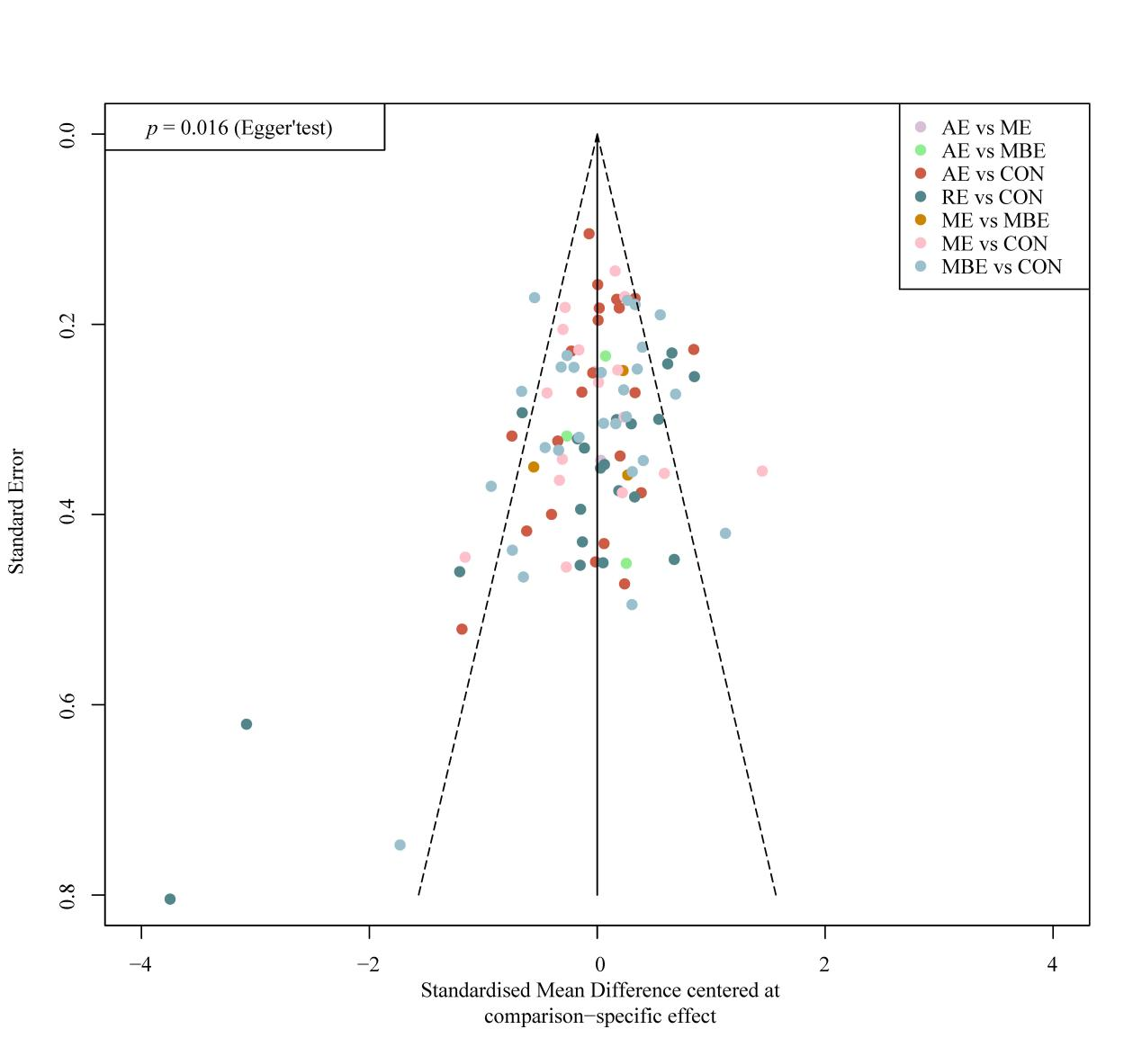
Figure S3. Comparison-adjusted funnel plot of all studies. AE, Aerobic exercise; RE, resistance exercise; ME, mix exercise; MBE, mind-body exercise.

Appendix 6. Network meta- analysis

S6.1 network diagrams
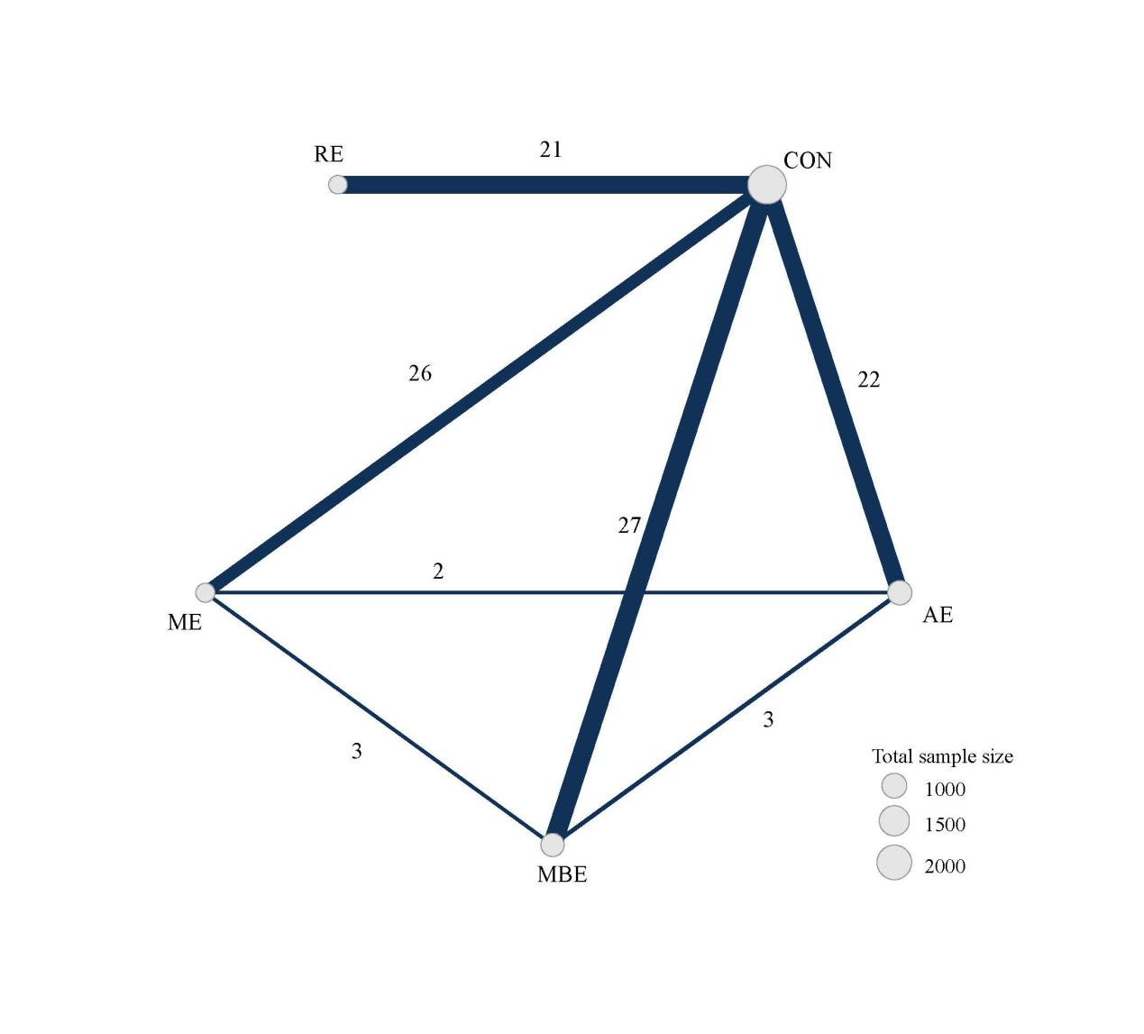
Figure S4a. Effects of four exercise types on depression levels in older adults. AE, Aerobic exercise; RE, resistance exercise; ME, mixed exercise; MBE, mind-body exercise; EG, exercise group.

S6.2 Table S3. Assessment of inconsistency within comparisons
Comparison | k | Direct | Indirect | Difference | z | P-value
AE vs CON | 22 | -0.3316 | -0.0968 | -0.2348 | -0.69 | 0.4918
AE vs MBE | 3 | 0.5655 | 0.148 | 0.4175 | 1.32 | 0.1867
AE vs ME | 2 | -0.0013 | -0.102 | 0.1008 | 0.27 | 0.7837
AE vs RE | 0 | NA | 0.3703 | NA | NA | NA
MBE vs CON | 27 | -0.5185 | -0.933 | 0.4145 | 1.05 | 0.2924
ME vs CON | 16 | -0.1951 | -0.4728 | 0.2776 | 0.81 | 0.4193
RE vs CON | 21 | -0.6821 | NA | NA | NA | NA
MBE vs ME | 3 | -0.2412 | -0.3357 | 0.0944 | 0.29 | 0.7681
MBE vs RE | 0 | NA | 0.1412 | NA | NA | NA
ME vs RE | 0 | NA | 0.4549 | NA | NA | NA
Note: AE, Aerobic exercise; RE, resistance exercise; ME, mix exercise; MBE, mind-body exercise.

S6.3 Dot splitting method to explore inconsistency
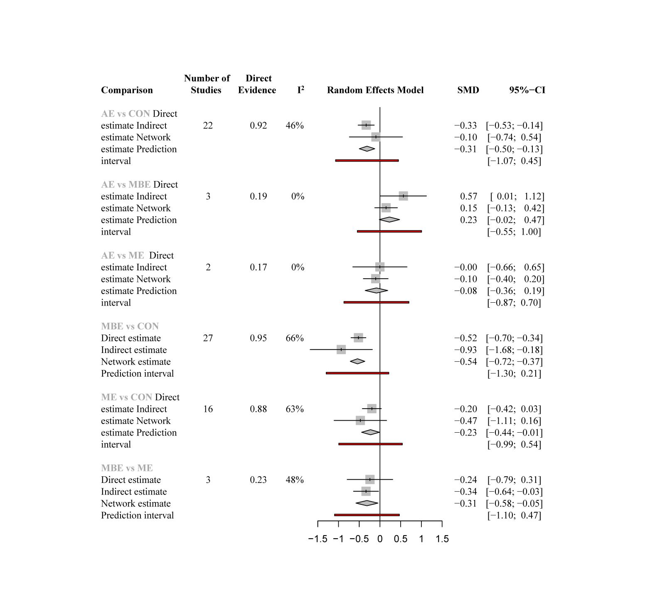
Figure S4b. Dot splitting method to explore inconsistency. I² represents the heterogeneity of pairwise comparisons and the red region represents the prediction interval. AE, Aerobic exercise; RE, resistance exercise; ME, mix exercise; MBE, mind-body exercise.

S6.4 Sensitivity analysis
6.4.1 Forest plot for sensitivity analysis
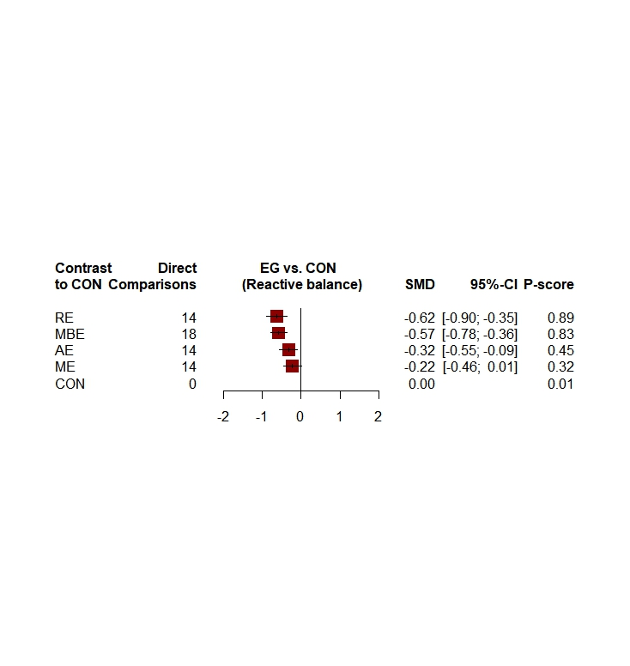
Figure S5a. Exclude high risk of bias forest plot
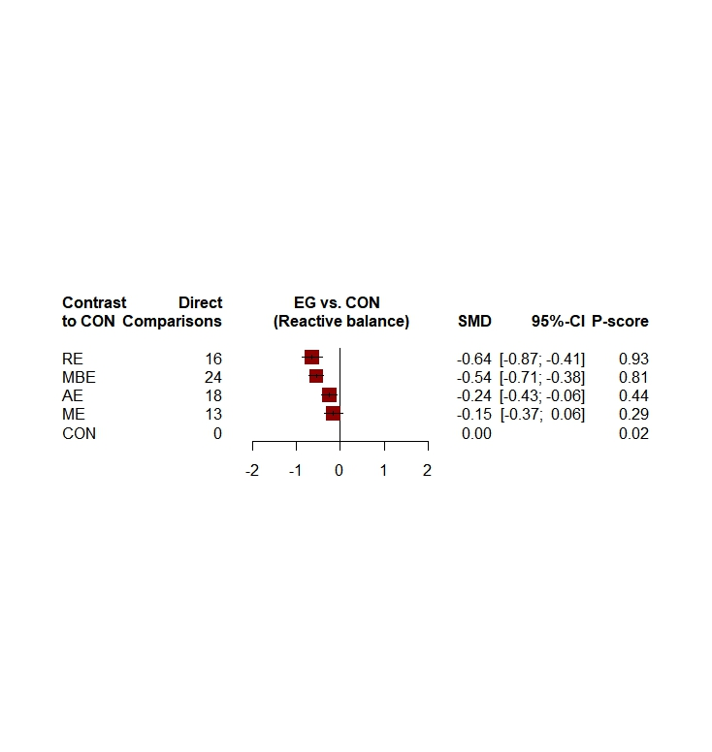

Figure S5b. Exclude small sample sizes forest plot
Figure S5. Forest plot of sensitivity analyses. AE, Aerobic exercise; RE, resistance exercise; ME, mix exercise; MBE, mind-body exercise.

6.4.2 League table for sensitivity analysis
Table S4. league table for sensitivity analyses
Exclude high risk of bias
AE | -0.33 (-0.57, -0.09) | 0.49 (-0.16, 1.13) | -0.00 (-0.66, 0.66) | .
-0.32 (-0.55, -0.09) | CON | 0.55 (0.33, 0.76) | 0.21 (-0.03, 0.45) | 0.62 (0.35, 0.90)
0.25 (-0.04, 0.55) | 0.57 (0.36, 0.78) | MBE | -0.47 (-1.35, 0.41) | NA
-0.09 (-0.40, 0.21) | 0.22 (-0.01, 0.46) | -0.35 (-0.65, -0.04) | ME | NA
0.30 (-0.05, 0.66) | 0.62 (0.35, 0.90) | 0.05 (-0.29, 0.40) | 0.40 (0.04, 0.76) | RE
Exclude small sample sizes
AE | -0.26 (-0.45, -0.07) | 0.56 (0.04, 1.09) | -0.00 (-0.61, 0.61) | NA
-0.24 (-0.43, -0.06) | CON | 0.53 (0.36, 0.70) | 0.11 (-0.12, 0.34) | 0.64 (0.41, 0.87)
0.30 (0.06, 0.54) | 0.54 (0.38, 0.71) | MBE | -0.24 (-0.76, 0.27) | NA
-0.09 (-0.36, 0.18) | 0.15 (-0.06, 0.37) | -0.39 (-0.65, -0.13) | ME | NA
0.39 (0.10, 0.69) | 0.64 (0.41, 0.87) | 0.09 (-0.19, 0.38) | 0.48 (0.17, 0.80) | RE
Note: AE, Aerobic exercise; RE, resistance exercise; ME, mix exercise; MBE, mind-body exercise.

S6.5 Network meta-regression
Network meta-regression analyses of depression were performed to investigate potential moderating variables.
Table S5. Model fit summaries for univariate network meta-regression.
Covariate | depression (80 data points)
 | DIC | pD | Residual  Deviance | Shared beta  (Median and 95% CI) | SD
Depression | 160.1 | 47.4 | 112.7 | 0.19 (0.03, 0.42) | 0.40 (0.30, 0.53)
Intervention  duration (weeks) | 169.5 | 56.5 | 113.1 | -0.09(-0.31, 0.15) | 0.40 (0.31, 0.53)
year of publication | 167.5 | 53.6 | 113.9 | -0.13(-0.36, 0.10) | 0.40 (0.30, 0.53)
Intervention frequency | 173.0 | 58.7 | 114.3 | 0.03 (-0.19, 0.25) | 0.40 (0.30, 0.53)
Percent  male | 172.8 | 58.2 | 114.6 | 0.03(-0.17, 0.25) | 0.40 (0.30, 0.53)
Note: DIC, deviance information criterion; SD, standard deviation.

S6.6 GRADE Assessment
Table S6. Details of GRADE assessment for all pairwise comparisons within the depression network.
Comparison | k | Direct SMD  [95% CI] | Quality of evidence | Indirect SMD  [95% CI] | Quality of evidence | Network SMD  [95% CI] | Quality of evidence | P-value
AE vs. CON | 22 | -0.33 (-0.53, -0.14) | Moderate* | -0.10 (-0.74, 0.54) | Low*† | -0.31 (-0.50, -0.13) | Moderate* | 0.491
MBE vs. CON | 27 | -0.52 (-0.70, 0-.34) | Moderate* | -0.93 (-1.68, 0.18) | Low*† | -0.54 (-0.72, -0.37) | Moderate* | 0.292
ME vs. CON | 16 | -0.20 (-0.42, -0.03) | Moderate* | -0.47 (-1.11, 0.16) | Low*† | -0.23 (-0.44, -0.01) | Moderate* | 0.419
RE vs. CON | 21 | -0.68 (-0.90, -0.46) | Moderate* | NA |  | -0.68 (-0.90, -0.46) | Moderate* | NA
AE vs. MBE | 3 | -0.57 (-1.12, -0.01) | Moderate* | 0.15 (-0.13, 0.42) | Low*† | -0.23 (-0.47, -0.02) | Low*† | 0.187
AE vs. ME | 2 | 0 (-0.65, 0.66) | Very low*‡ | -0.10 (-0.40, 0.20) | Very low*‡ | -0.08 (-0.19, 0.36) | Very low*‡ | 0.784
AE vs. RE | 0 | NA |  | NA |  | -0.37 (-0.66, -0.08) | Low*† | NA
MBE vs. ME | 3 | -0.24 (-0.79, 0.31) | Very low*‡ | -0.34 (-0.64, -0.03) | Low*† | 0.31 (-0.58, -0.05) | Low*† | 0.768
MBE vs. RE | 0 | NA |  | NA |  | -0.14 (-0.42, 0.14) | Very low*‡ | NA
ME vs. RE | 0 | NA |  | NA |  | -0.45 (-0.76, -0.15) | Low*† | NA

k = Number of studies providing direct evidence, prop = proportion of direct evidence, NMA (SMD) = estimated treatment effect (SMD) in network meta-analysis, direct (SMD) = estimated treatment effect (SMD) derived from direct evidence, indirect (SMD) = estimated treatment effect (SMD) derived from indirect evidence, p = p-value of test for disagreement (difference between direct and indirect evidence)
Reasons for downgrading: †Imprecision (1 downgrade), ‡Severe imprecision (2 downgrades), *risk of bias (1 downgrade)
The p-value indicated that the findings between direct and indirect comparisons was not statistically significant and therefore no comparisons have been downgraded based on inconsistency.

Appendix7. Dose network meta- analysis

S7.1 Table S7. Dataset
This Appendix shows the datasets (i.e., at global exercise and agent levels) used in this study. The studyID indicates the name of the author and the year of publication. The y indicates the mean change from the baseline of the evaluation tool. The se indicates the standard error of the mean. The agent indicates the agent level. The Mets session indicates the energy expenditure in a session of the study. The exact_dose parameter indicates the exact estimated METs per week that participants accumulated in the study. The dose indicates the group of doses by approximation. The residual_dose indicates the difference between the exact dose and the dose allocated by approximation. The frequency is the number of days those participants were involved in physical activity. The min_day indicates how many minutes a session lasted. The N indicates the number of participants.
Study | Agent | MET | Mets session | Exact dose | dose | Residual dose | Frequency | Min/day
Angeles (2016) | Mixed exercise | 2.3 | 138 | 354 | 300 | 54 | 3 | 60
Ansai (2015) | Resistance exercise | 3.5 | 210 | 648 | 600 | 48 | 3 | 60
Antunes (2005) | Aerobic exercise | 8 | 320 | 960 | 1200 | 240 | 3 | 40
Baklouti(2023) | Mind-body exercise | 2.5 | 200 | 400 | 300 | 100 | 2 | 80
Bernard (2015) | Aerobic exercise | 4.8 | 192 | 384 | 300 | 84 | 2 | 40
Bethany (2005) | Aerobic exercise | 3.8 | 114 | 342 | 300 | 42 | 3 | 30
Bethany (2005) | Aerobic exercise | 4.5 | 135 | 405 | 300 | 105 | 3 | 30
Bethany (2005) | Mind-body exercise | 2.8 | 84 | 252 | 300 | 48 | 3 | 30
Blumenthal (1991) Females | Mixed exercise | 6 | 360 | 1080 | 1200 | 120 | 3 | 60
Blumenthal (1991) Females | Mind-body exercise | 2.3 | 138 | 414 | 300 | 114 | 3 | 60
Blumenthal (1991) males | Mixed exercise | 6 | 360 | 1080 | 1200 | 120 | 3 | 60
Blumenthal (1991) males | Mind-body exercise | 2.3 | 138 | 414 | 300 | 114 | 3 | 60
Bonura (2014) | Mixed exercise | 2.3 | 103.5 | 104 | 300 | 196 | 1 | 45
Bonura (2014) | Mind-body exercise | 2.3 | 103.5 | 104 | 300 | 196 | 1 | 45
Bouaziz (2019) | Aerobic exercise | 8 | 240 | 480 | 600 | 120 | 2 | 30
Brenes (2007) | Mixed exercise | 5 | 300 | 900 | 900 | 0 | 3 | 60
Brown (2009) | Mixed exercise | 2.3 | 138 | 276 | 300 | 24 | 2 | 60
Chen (2009) | Mind-body exercise | 2.5 | 175 | 525 | 600 | 75 | 3 | 70
Chen (2023) | Resistance exercise | 5.5 | 275 | 550 | 600 | 50 | 2 | 50
Cheng (2012) | Mind-body exercise | 3 | 180 | 540 | 600 | 60 | 3 | 60
Chin A Paw (2004) | Resistance exercise | 5 | 262.5 | 500 | 600 | 100 | 2 | 52.5
Choi (2018) | Mind-body exercise | 2.8 | 70 | 392 | 300 | 92 | 4 | 25
Chou(2004) | Mind-body exercise | 3 | 135 | 405 | 300 | 105 | 3 | 45
Clegg (2014) | Resistance exercise | 3.5 | 52.5 | 788 | 900 | 112 | 15 | 15
Collier (1997) | Resistance exercise | 3.5 | 175 | 525 | 600 | 75 | 3 | 50
Conradsson (2010) | Mixed exercise | 6 | 270 | 675 | 600 | 75 | 2.5 | 45
Damush(1999) | Resistance exercise | 5.5 | 247.5 | 495 | 600 | 105 | 2 | 45
Dong (2013) | Mind-body exercise | 3 | 180 | 540 | 600 | 60 | 3 | 60
Emery (1990) | Mixed exercise | 5 | 300 | 900 | 900 | 0 | 3 | 60
Fakhari (2017) | Mind-body exercise | 3 | 67.5 | 225 | 300 | 75 | 3 | 22.5
Favilla (1992) | Resistance exercise (moderate) | 5.5 | 330 | 990 | 900 | 90 | 3 | 60
Favilla (1992) | Resistance exercise (high) | 9 | 540 | 1620 | 1200 | 420 | 3 | 60
Frye (2007) | Mind-body exercise | 3 | 180 | 540 | 600 | 60 | 3 | 60
Ge(2021) | Mind-body exercise | 3 | 180 | 540 | 600 | 60 | 3 | 60
Gusi (2008) | Aerobic exercise | 5 | 250 | 750 | 900 | 150 | 3 | 50
Haboush (2006) | Aerobic exercise | 5.5 | 247.5 | 248 | 300 | 52 | 1 | 45
Hars (2014) | Aerobic exercise | 5 | 300 | 300 | 300 | 0 | 1 | 60
Huang (2015) | Mixed exercise | 5 | 250 | 750 | 900 | 150 | 3 | 50
Irwin (2012) | Mind-body exercise | 3 | 120 | 360 | 300 | 60 | 3 | 40
Irwin (2014) | Mind-body exercise | 3 | 360 | 360 | 300 | 60 | 1 | 120
Karapınar(2022) | Mixed exercise | 5 | 200 | 1000 | 1200 | 200 | 5 | 40
Kekalaine (2018) | Resistance exercise (low) | 5 | 300 | 300 | 300 | 0 | 1 | 60
Kekalaine (2018) | Resistance exercise (moderate) | 5 | 300 | 600 | 600 | 0 | 2 | 60
Kekalaine (2018) | Resistance exercise (high) | 5 | 300 | 900 | 900 | 0 | 3 | 60
Kerse(2010) | Mixed exercise | 5 | 150 | 450 | 600 | 150 | 3 | 30
Kim (2019) | Resistance exercise | 5 | 225 | 675 | 600 | 75 | 3 | 45
Kohut (2005) | Aerobic exercise | 8.8 | 220 | 660 | 600 | 60 | 3 | 25
Krishnamurthy (2007) | Mind-body exercise | 2.8 | 210 | 1260 | 1200 | 60 | 6 | 75
Kuo (2018) | Aerobic exercise | 10 | 300 | 600 | 600 | 0 | 2 | 30
Kupecz (2001) | Aerobic exercise | 4.5 | 202.5 | 608 | 600 | 8 | 3 | 45
Lavretsky(2021) | Mind-body exercise | 3 | 180 | 180 | 300 | 120 | 1 | 60
Lee(2023) | Mixed exercise | 5 | 250 | 750 | 900 | 150 | 3 | 50
Li (2001) | Mind-body exercise | 3 | 135 | 405 | 300 | 105 | 3 | 45
Lin (2007) | Mixed exercise | 6 | 300 | 900 | 900 | 0 | 3 | 50
Lincoln (2011) | Resistance exercise | 5.5 | 247.5 | 743 | 600 | 143 | 3 | 45
Lok (2017) | Aerobic exercise | 3.5 | 245 | 980 | 1200 | 220 | 4 | 70
Maki (2012) | Aerobic exercise | 6 | 540 | 540 | 600 | 60 | 1 | 90
Makizako (2019) | Mixed exercise | 5 | 450 | 450 | 600 | 150 | 1 | 90
Martinez (2015) | Mind-body exercise | 3 | 270 | 540 | 600 | 60 | 2 | 90
Martins (2011) | Aerobic exercise | 8 | 360 | 1080 | 1200 | 120 | 3 | 45
McMurdo (1993) | Resistance exercise | 5 | 225 | 450 | 600 | 150 | 2 | 45
McNeil(1991) | Aerobic exercise | 7 | 210 | 630 | 600 | 30 | 3 | 30
Mortazavi (2012) | Aerobic exercise | 7.3 | 328.5 | 657 | 600 | 57 | 2 | 45
Ng (2017) | Mixed exercise | 5 | 450 | 900 | 900 | 0 | 2 | 90
Noradechanunt (2017) | Mind-body exercise | 3 | 240 | 480 | 600 | 120 | 2 | 80
Noradechanunt (2017) | Mind-body exercise | 2.5 | 200 | 400 | 300 | 100 | 2 | 80
Nyberg(2014) | Resistance exercise | 5.5 | 330 | 990 | 1200 | 210 | 3 | 60
Oken (2006) | Aerobic exercise | 7 | 420 | 420 | 300 | 120 | 1 | 60
Oken (2006) | Mind-body exercise | 2.5 | 225 | 225 | 300 | 75 | 1 | 90
Patel (2004) | Aerobic exercise | 7 | 140 | 420 | 300 | 120 | 3 | 20
Pedersen (2017) | Resistance exercise | 6 | 360 | 720 | 600 | 120 | 2 | 60
Prakhinkit (2014) | Aerobic exercise | 7 | 175 | 525 | 600 | 75 | 3 | 25
Prakhinkit (2014) | Mixed exercise | 2.3 | 57.5 | 173 | 300 | 127 | 3 | 25
Ramanathan (2017) | Mind-body exercise | 2.8 | 168 | 336 | 300 | 36 | 2 | 60
Roswiyani (2019) | Mind-body exercise | 3 | 270 | 540 | 600 | 60 | 2 | 90
Sahin (2018) | Resistance exercise (moderate) | 5.5 | 220 | 660 | 600 | 60 | 3 | 40
Sahin (2018) | Resistance exercise (high) | 9 | 360 | 1080 | 1200 | 120 | 3 | 40
Shahidi (2011) | Aerobic exercise | 7 | 210 | 420 | 300 | 120 | 2 | 30
Shahidi (2011) | Mind-body exercise | 2.8 | 84 | 168 | 300 | 132 | 2 | 30
Shahtahmassebi(2022) | Mixed exercise | 5 | 300 | 900 | 900 | 0 | 3 | 60
Shahtahmassebi(2022) | Aerobic exercise | 5 | 300 | 900 | 900 | 0 | 3 | 60
Singh (1997) | Resistance exercise | 5.5 | 275 | 825 | 900 | 75 | 3 | 50
Singh (2001) | Resistance exercise | 5.5 | 330 | 990 | 1200 | 210 | 3 | 60
Singh (2005) | Resistance exercise (moderate) | 5.5 | 357.5 | 1073 | 1200 | 127 | 3 | 65
Singh (2005) | Resistance exercise (high) | 9 | 585 | 1755 | 1200 | 555 | 3 | 65
Sola-Serrabou (2019) | Resistance exercise | 6 | 360 | 720 | 600 | 120 | 2 | 60
Song (2019) | Aerobic exercise | 7 | 420 | 1260 | 1200 | 60 | 3 | 60
Swoap (1994) | Aerobic exercise (moderate) | 7 | 332.5 | 945 | 900 | 45 | 3 | 47.5
Swoap (1994) | Aerobic exercise(high) | 9.8 | 465.5 | 1323 | 1200 | 123 | 3 | 47.5
Tapps (2013) | Resistance exercise | 5.5 | 165 | 495 | 600 | 105 | 3 | 30
Tsang (2013) | Mind-body exercise | 3 | 180 | 360 | 300 | 60 | 2 | 60
Tsang(2006) | Mind-body exercise | 3 | 112.5 | 337 | 300 | 37 | 3 | 37.5
Tsutsumi (1998) | Resistance exercise (moderate) | 5.5 | 220 | 660 | 600 | 60 | 3 | 40
Tsutsumi (1998) | Resistance exercise (high) | 9 | 360 | 1080 | 1200 | 120 | 3 | 40
Vankova (2014) | Aerobic exercise | 5.5 | 330 | 330 | 300 | 30 | 1 | 60
Wang (2010) | Mind-body exercise | 2.5 | 150 | 150 | 300 | 150 | 1 | 60
Williams (2008) | Aerobic exercise | 7 | 210 | 1050 | 1200 | 150 | 5 | 30
Williams (2008) | Mixed exercise | 5 | 150 | 750 | 900 | 150 | 5 | 30
Zanuso (2012) | Resistance exercise | 5.5 | 330 | 990 | 1200 | 210 | 3 | 60

S7.2 Key assumptions of Network Meta-Analysis
The following are the three key assumptions of the network meta-analysis.

S7.2.1 Connectivity
Connectivity is a key assumption in NMA that, if considered insufficient (i.e., due to lack of direct comparisons), may lead to low statistical power and misleading results. Our study assessed network connectivity at the motor and dose levels and did not find any evidence of network unconnectedness (Figure S6 and Figure S7).
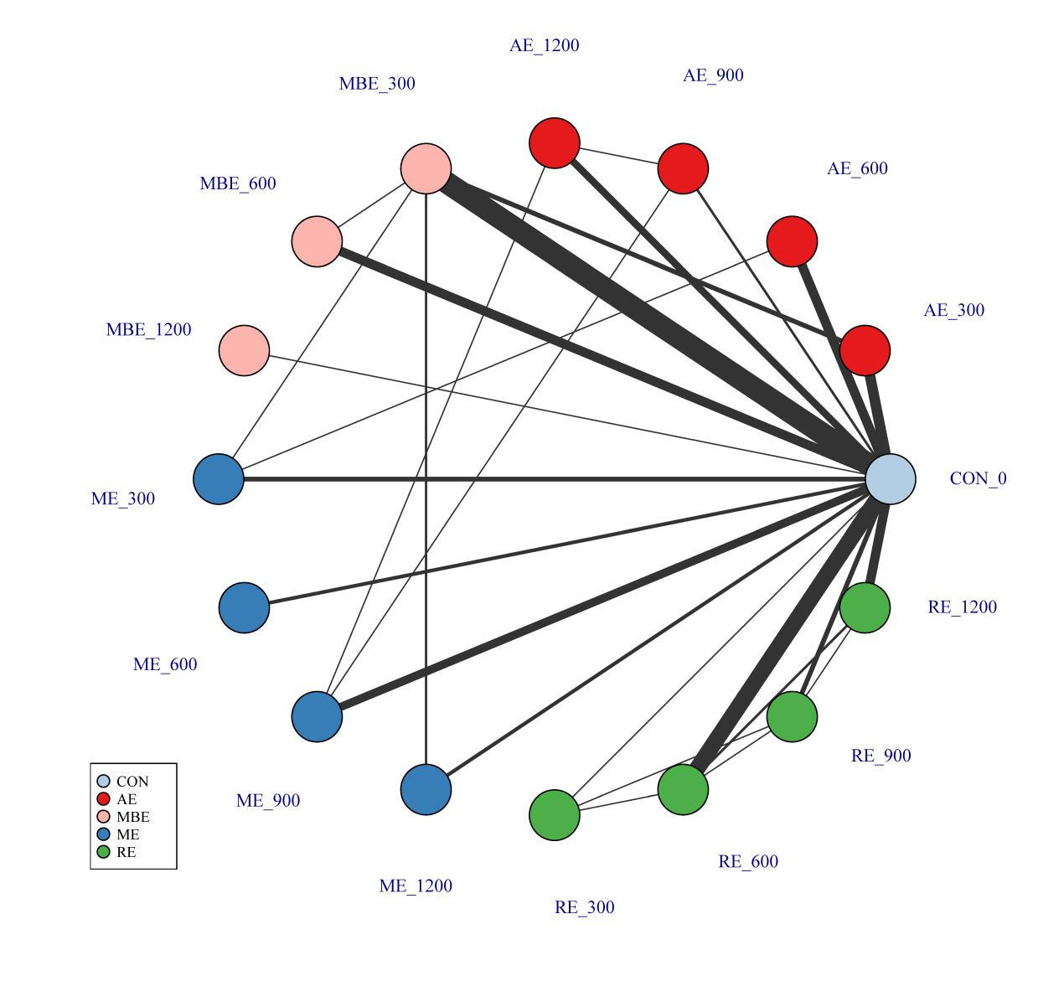
Figure S6. Treatment-level network. The first value indicates the specific intervention and the second one is the corresponding dose of that intervention. AE, Aerobic exercise; RE, resistance exercise; ME, mix exercise; MBE, mind-body exercise; CON, control.
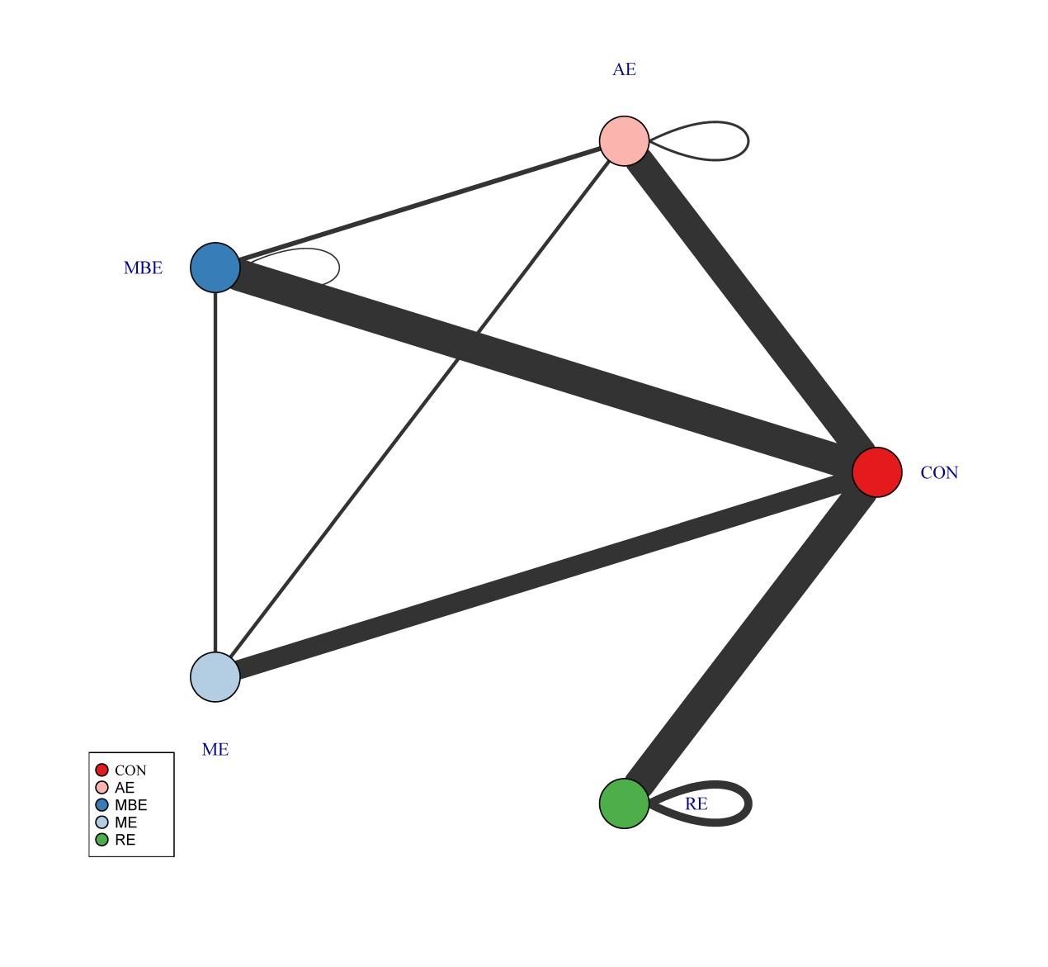
Figure S7. Agent-level network. AE, Aerobic exercise; RE, resistance exercise; ME, mix exercise; MBE, mind-body exercise; CON, control..

S7.2.2 Consistency
We performed a consistency analysis of the data by comparing the consistency of the network (i.e., network effect size) with the unrelated mean effects (UME) model (i.e., pairwise effect sizes). In practice, we checked whether the bias, the number of estimated parameters in the network, and the Deviance Information Criterion (DIC) metric were similar for both models, indicating a good fit (Wheeler et al., 2010). The comparison of these parameters showed a good agreement between the different models (Table S1).
Table S8. Consistent and UME models fit comparison
Model | pD | Deviance | Residual deviance | DIC
Consistent | 174.1 | 379.77 | 180.24 | 571.0
UME | 173.7 | 397.75 | 180.23 | 570.6
Note: pD: Number of estimated parameters; DIC: Deviance Informative Criterion; SD: Standard
Deviation; UME: Unrelated Mean Effects. Scientific literature indicated that the main indicator to
assess the model fit is the DIC. As lower DIC, better fit.

S7.2.3 Transitivity
NMAs are based on the assumption of indirect/mixed comparisons, which implies that estimates of treatment effects from direct and indirect evidence are consistent but with the usual variation of meta-analyses under a random effects model (White et al., 2012). This assumption is equivalent to heterogeneity in a "standard" meta-analysis (Cipriani et al., 2013). Following a previous proposal (Salanti et al., 2014), anomalies were assessed at a deeper network level (i.e., at the treatment level). We assessed the span by the MBNMA node splitting method. This method splits the contribution of a specific treatment contrast into direct and indirect evidence and compares them (Van Valkenhoef et al., 2016). Similar effects indicate good span. Table S2 presents the results for transitivity in this meta-analysis.
Table S9. Node-splitting analysis of inconsistency
Comparison | p-value | Median | 2.50% | 97.50%
ME_900 vs AE_900 | 0.404
-> direct |  | 0.253 | -5.401 | 6.191
-> indirect |  | -0.253 | -1.607 | 1.166
-> MBNMA |  | -0.232 | -1.566 | 1.081
RE_1200 vs Placebo_0 | 0.725
-> direct |  | -2.544 | -4.334 | -0.722
-> indirect |  | -2.131 | -3.389 | -0.947
-> MBNMA |  | -2.21 | -3.219 | -1.203
RE_900 vs Placebo_0 | 0.643
-> direct |  | -2.293 | -4.673 | 0.071
-> indirect |  | -2.074 | -3.157 | -0.947
-> MBNMA |  | -2.204 | -3.173 | -1.196
RE_600 vs Placebo_0 | 0.666
-> direct |  | -2.373 | -3.659 | -1.052
-> indirect |  | -1.765 | -3.375 | -0.334
-> MBNMA |  | -2.187 | -3.139 | -1.188
RE_300 vs Placebo_0 | 0.169
-> direct |  | 1.158 | -3.908 | 5.937
-> indirect |  | -2.299 | -3.327 | -1.197
-> MBNMA |  | -2.138 | -3.091 | -1.139
ME_1200 vs Placebo_0 | 0.62
-> direct |  | -1.048 | -3.904 | 1.803
-> indirect |  | -1.292 | -2.435 | 0
-> MBNMA |  | -1.287 | -2.404 | -0.173
ME_600 vs Placebo_0 | 0.432
-> direct |  | -0.168 | -2.859 | 2.359
-> indirect |  | -1.522 | -2.765 | -0.271
-> MBNMA |  | -1.28 | -2.382 | -0.166
ME_300 vs Placebo_0 | 0.144
-> direct |  | -3.331 | -5.497 | -1.012
-> indirect |  | -0.742 | -2.033 | 0.425
-> MBNMA |  | -1.268 | -2.363 | -0.156
MBE_1200 vs Placebo_0 | 0.3
-> direct |  | -4.219 | -8.821 | 0.505
-> indirect |  | -2.421 | -3.493 | -1.438
-> MBNMA |  | -2.462 | -3.536 | -1.524
MBE_600 vs Placebo_0 | 0.772
-> direct |  | -2.409 | -4.231 | -0.695
-> indirect |  | -2.506 | -3.701 | -1.368
-> MBNMA |  | -2.449 | -3.433 | -1.517
MBE_300 vs Placebo_0 | 0.668
-> direct |  | -2.532 | -3.746 | -1.379
-> indirect |  | -1.956 | -3.551 | -0.457
-> MBNMA |  | -2.414 | -3.344 | -1.473
AE_1200 vs Placebo_0 | 0.594
-> direct |  | -1.559 | -3.635 | 0.492
-> indirect |  | -0.898 | -2.036 | 0.124
-> MBNMA |  | -1.058 | -2.018 | -0.072
AE_600 vs Placebo_0 | 0.444
-> direct |  | -1.749 | -3.404 | -0.002
-> indirect |  | -0.645 | -1.826 | 0.437
-> MBNMA |  | -1.049 | -1.955 | -0.07
AE_300 vs Placebo_0 | 0.755
-> direct |  | -1.228 | -2.998 | 0.498
-> indirect |  | -0.922 | -2.078 | 0.15
-> MBNMA |  | -1.034 | -1.947 | -0.066

S7.3 Models’ selection
S7.3.1 Non-linear functions and models fit comparison
A meta-analysis (i.e., a "split" NMA) of the different doses of physical activity as separate and unrelated treatments were performed. This step helps determine which function is more appropriate for the data and should be used in a model-based network meta-analysis (MBNMA) (Mawdsley et al., 2016). Figure S8 and Figure S9 show the different responses of each dose to overall and different types of exercise, respectively (Hedges' g).
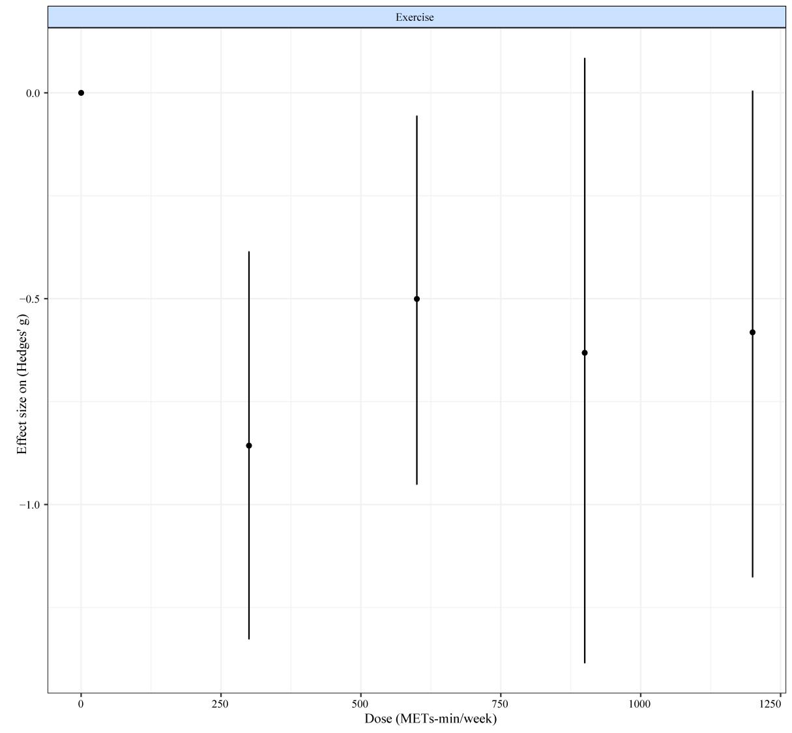
Figure S8. “Split” NMA of overall exercise

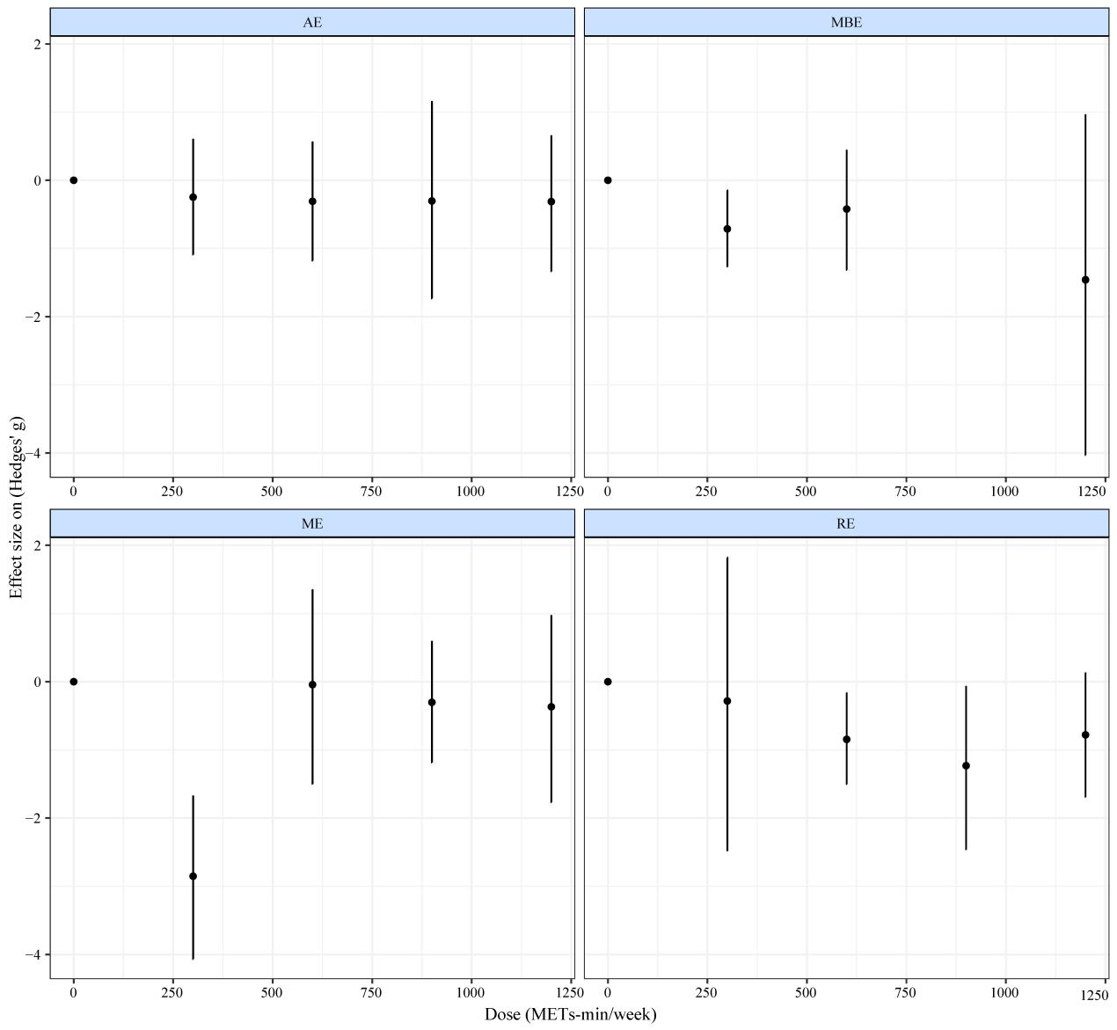
Figure S9. “Split” NMA of different exercise agents. AE, Aerobic exercise; RE, resistance exercise; ME, mix exercise; MBE, mind-body exercise.

S7.3.2 Models selection
For our data, quadratic model shows the best fit and were therefore used in subsequent analyses.

Table S10. Models fit comparison
Model | DIC | SD | Deviance | Residual deviance | pD
Emax (random treatment effects) | 571.3 | NA | 397.95 | 180.42 | 173.9
Restricted cubic spline (common treatment effects; 3 knots) | 1701.6 | NA | 1606.37 | 1388.84 | 95.8
Restricted cubic spline (random treatment effects; 3 knots) | 570.7 | 1.26  (1.07, 1.49) | 397.97 | 180.44 | 173.8
Exponential (common treatment effects) | 1866.2 | NA | 1782.19 | 1564.66 | 84.6
Quadratic (random treatment effects) | 570.1 | 1.32  (1.12, 1.55) | 397.38 | 179.85 | 174.2
Note. DIC = Deviance Information Criterion; SD = Between-study Standard Deviation; pD: Number of estimated parameters; NA = Not Applicable. The SD is presented as the main value and (95% Credible Intervals).

In addition to the model fit index, a deviation plot showing the contribution of each data point to the residuals can also help to confirm the robustness of the model selection. The contribution of each data point to the posterior mean bias should be around 1, which indicates a good model fit (Dias et al., 2013). Deviation plots for overall (Figure S10) and treatment effects (Figure S11) confirm the robustness of our model selection (i.e., deviations <1.5 except for a few data points in the overall exercise and stretch at 300 METs-min, which are all below a contribution of 1.5).
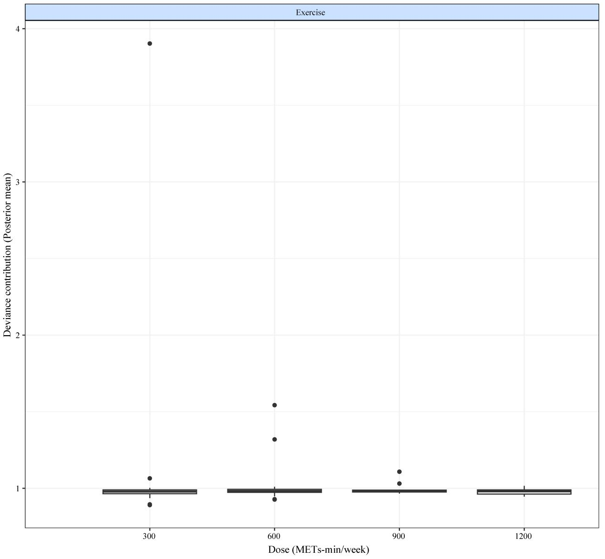
Figure S10. Deviance plot at overall exercise level.
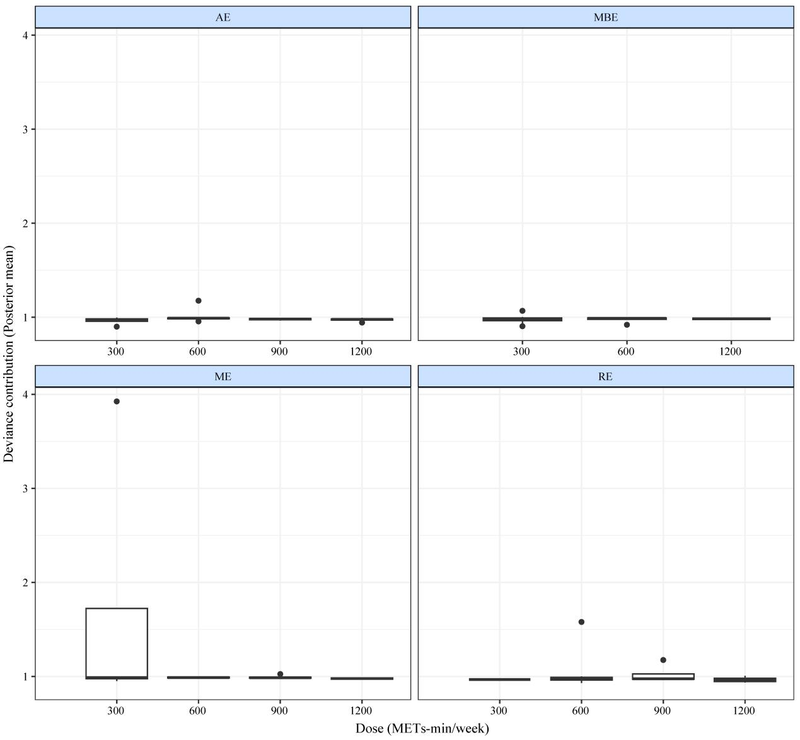
Figure S11. Deviance plots at treatment-level.
In order to determine the appropriateness of the model, we conducted a goodness-of-fit analysis. The goodness-of-fit metrics are displayed as interconnected lines, with the original dataset observations being represented by individual data points. These visuals are utilized to evaluate the model’s ability to accommodate variations in exercise and dosage-response functions (Figure S12 and Figure S13).
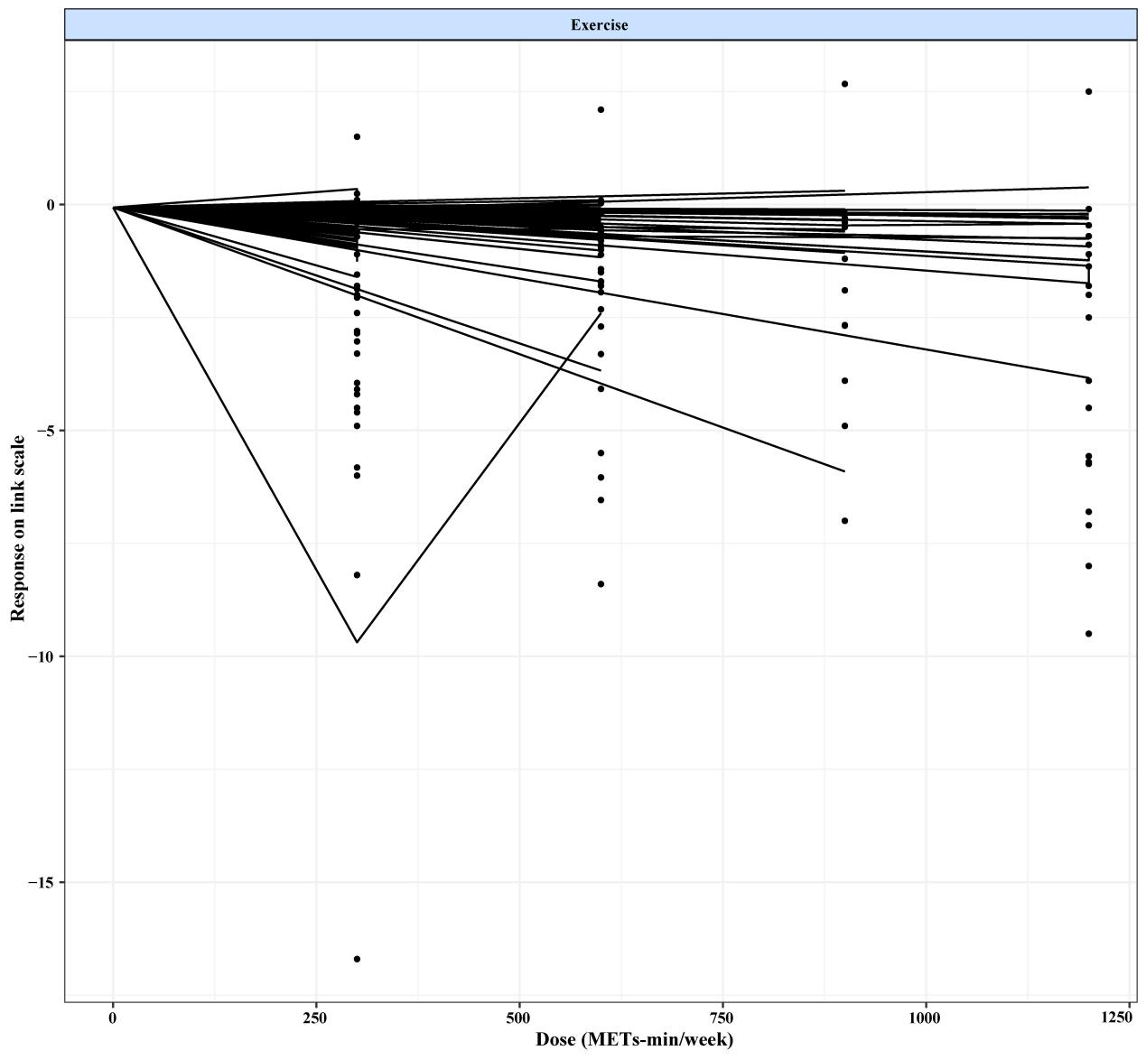
Figure S12. Fit plots at overall exercise level.
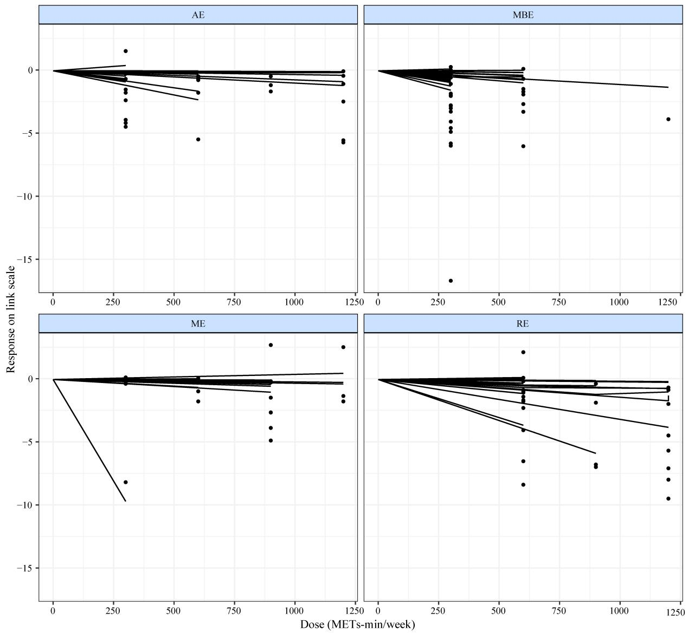
Figure S13. Fit plots at agent-level.

S7.4 Dose-response relationships

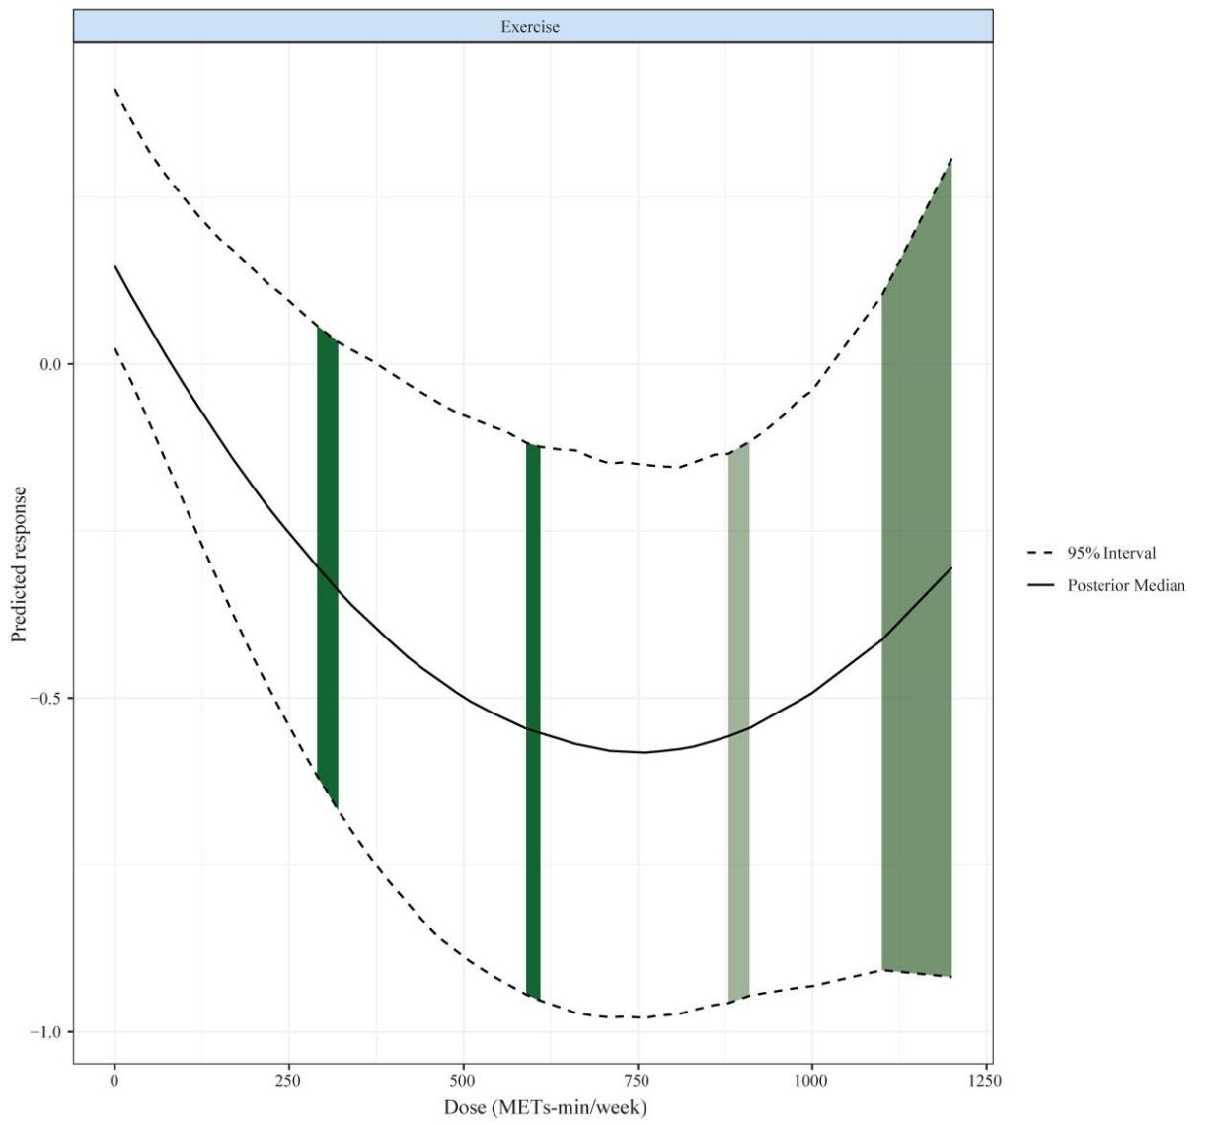
Figure S16. Exercise dose-response relationship at agent-level.
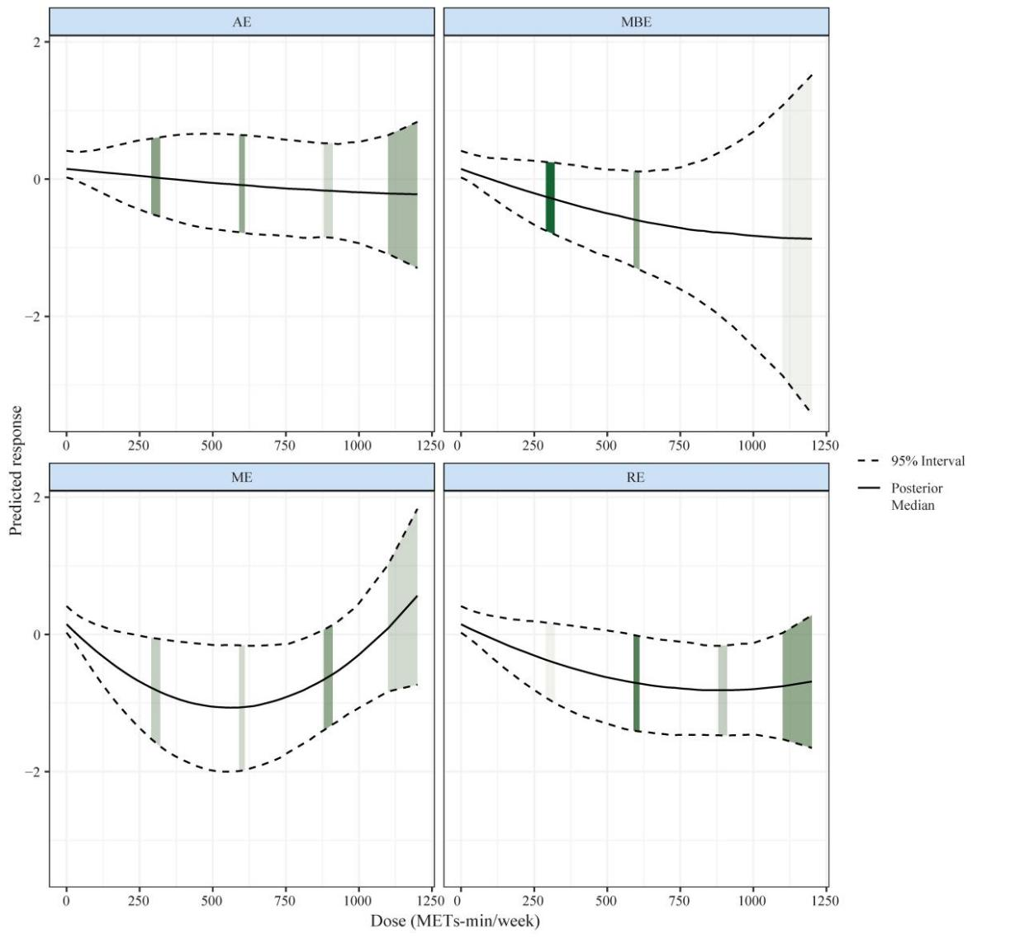
Figure S17. Number of original studies at different dose scenarios, the darker the color, the larger the amount of data.

S7.5 Predicted responses
Table S12 shows the predicted effects of the lower limits of the WHO-recommended levels of physical activity.

Table S13. Predicted responses
Agent | Exercise Dose  (METs-min/week) | Mean | 95% CrI | SD
AE | 600 | -0.09 | (-0.81, 0.64) | 0.37
MBE | 600 | -0.58 | (-1.27, 0.12) | 0.36
ME | 560* | -1.05 | (-1.96, -0.15) | 0.46
RE | 600* | -0.72 | (-1.42, -0.03) | 0.35
Note: *: The maximum predicted dose of ME is 560 METs per week. Bolded numbers indicate the presence of significance. CrI, credible interval. SD, standard deviation. AE, Aerobic exercise; RE, resistance exercise; ME, mix exercise; MBE, mind-body exercise.

S7.6 Ranking of effectiveness of interventions
Figure S12 shows the probability of each intervention to be ranked from worst to best (estimated after up to 4000 iterations).
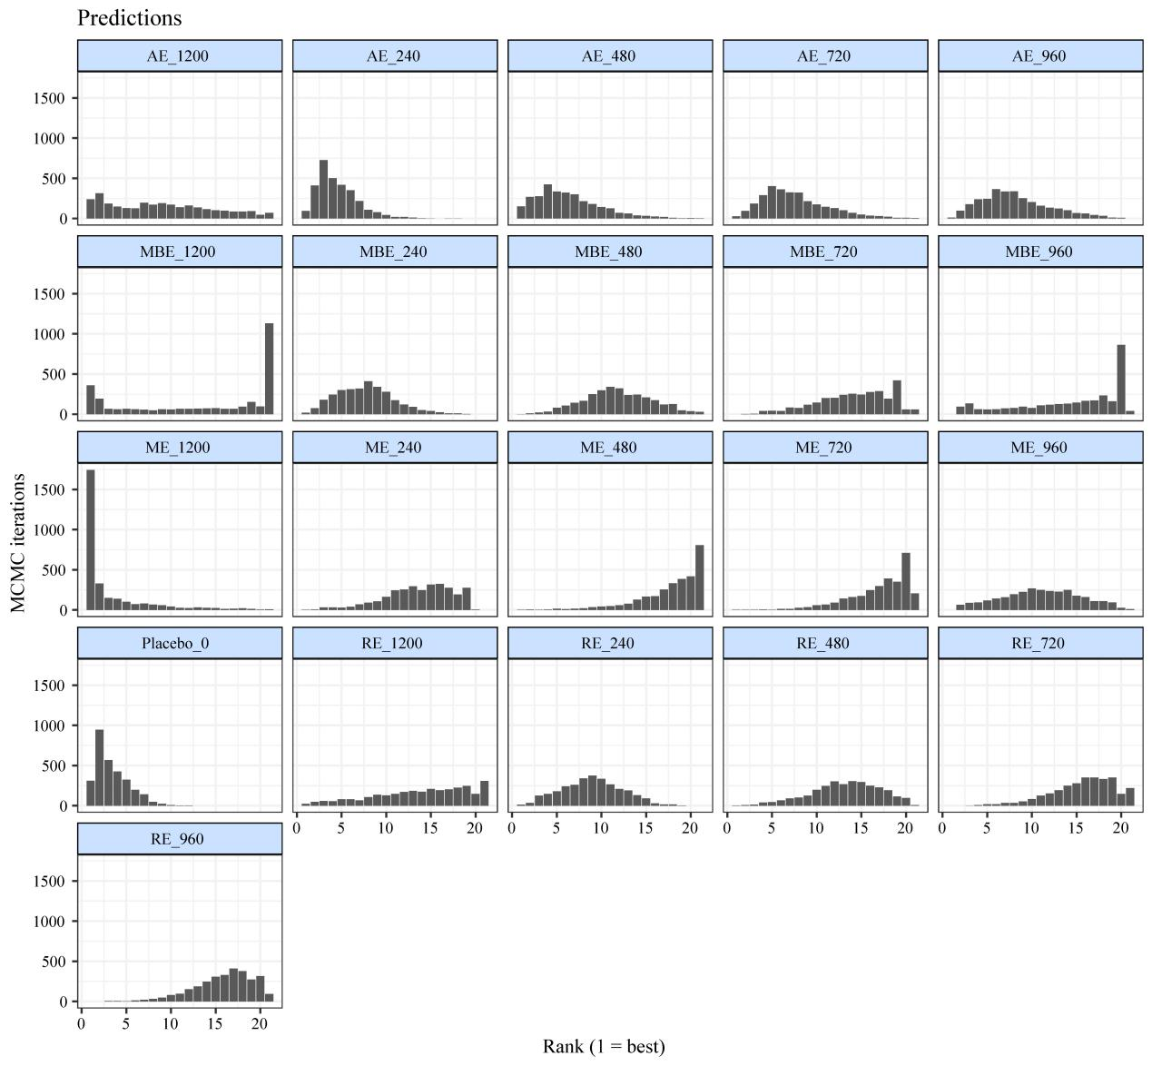
Figure S12. Effectiveness ranking by exercise treatments. The number that follows the exercise intervention indicates the dose of exercise (METs-min/week).

References
Ainsworth, B. E., Haskell, W. L., Herrmann, S. D., Meckes, N., Bassett, D. R., Jr., Tudor-Locke, C., Greer, J. L., Vezina, J., Whitt-Glover, M. C., & Leon, A. S. (2011). 2011 Compendium of Physical Activities: a second update of codes and MET values. Med Sci Sports Exerc, 43(8), 1575-1581. https://doi.org/10.1249/MSS.0b013e31821ece12
Bagby, R. M., Ryder, A. G., Schuller, D. R., & Marshall, M. B. (2004). The Hamilton Depression Rating Scale: has the gold standard become a lead weight? American Journal of Psychiatry, 161(12), 2163-2177.
Beck, A. T., Steer, R. A., & Carbin, M. G. (1988). Psychometric properties of the Beck Depression Inventory: Twenty-five years of evaluation. Clinical Psychology Review, 8(1), 77-100.
Cipriani, A., Higgins, J. P., Geddes, J. R., & Salanti, G. (2013). Conceptual and technical challenges in network meta-analysis. Ann Intern Med, 159(2), 130-137. https://doi.org/10.7326/0003-4819-159-2-201307160-00008
Dias, S., Sutton, A. J., Ades, A. E., & Welton, N. J. (2013). Evidence synthesis for decision making 2: a generalized linear modeling framework for pairwise and network meta-analysis of randomized controlled trials. Med Decis Making, 33(5), 607-617. https://doi.org/10.1177/0272989x12458724
Dias, S., Welton, N. J., Caldwell, D. M., & Ades, A. E. (2010). Checking consistency in mixed treatment comparison meta-analysis. Stat Med, 29(7-8), 932-944. https://doi.org/10.1002/sim.3767
Evans, N. J. (2019). Assessing the practical differences between model selection methods in inferences about choice response time tasks. Psychon Bull Rev, 26(4), 1070-1098. https://doi.org/10.3758/s13423-018-01563-9
Higgins, J. P., Jackson, D., Barrett, J. K., Lu, G., Ades, A. E., & White, I. R. (2012). Consistency and inconsistency in network meta-analysis: concepts and models for multi-arm studies. Res Synth Methods, 3(2), 98-110. https://doi.org/10.1002/jrsm.1044
Higgins, J. P., & Thompson, S. G. (2002). Quantifying heterogeneity in a meta‐analysis. Stat Med, 21(11), 1539-1558.
Kørner, A., Lauritzen, L., Abelskov, K., Gulmann, N., Marie Brodersen, A., Wedervang-Jensen, T., & Marie Kjeldgaard, K. (2006). The geriatric depression scale and the cornell scale for depression in dementia. A validity study. Nordic journal of psychiatry, 60(5), 360-364.
Lewinsohn, P. M., Seeley, J. R., Roberts, R. E., & Allen, N. B. (1997). Center for Epidemiologic Studies Depression Scale (CES-D) as a screening instrument for depression among community-residing older adults. Psychol Aging, 12(2), 277.
Lin, L., Chu, H., Murad, M. H., Hong, C., Qu, Z., Cole, S. R., & Chen, Y. (2018). Empirical Comparison of Publication Bias Tests in Meta-Analysis. J Gen Intern Med, 33(8), 1260-1267. https://doi.org/10.1007/s11606-018-4425-7
Mawdsley, D., Bennetts, M., Dias, S., Boucher, M., & Welton, N. J. (2016). Model-Based Network Meta-Analysis: A Framework for Evidence Synthesis of Clinical Trial Data. CPT Pharmacometrics Syst Pharmacol, 5(8), 393-401. https://doi.org/10.1002/psp4.12091
Miller, K. J., Gonçalves-Bradley, D. C., Areerob, P., Hennessy, D., Mesagno, C., & Grace, F. (2020). Comparative effectiveness of three exercise types to treat clinical depression in older adults: A systematic review and network meta-analysis of randomised controlled trials. Ageing Res Rev, 58, 100999. https://doi.org/10.1016/j.arr.2019.100999
Pedder, H., Dias, S., Bennetts, M., Boucher, M., & Welton, N. J. (2019). Modelling time-course relationships with multiple treatments: Model-based network meta-analysis for continuous summary outcomes. Res Synth Methods, 10(2), 267-286. https://doi.org/10.1002/jrsm.1351
Rücker, G., & Schwarzer, G. (2015). Ranking treatments in frequentist network meta-analysis works without resampling methods. BMC Med Res Methodol, 15, 58. https://doi.org/10.1186/s12874-015-0060-8
Salanti, G., Del Giovane, C., Chaimani, A., Caldwell, D. M., & Higgins, J. P. (2014). Evaluating the quality of evidence from a network meta-analysis. PLoS One, 9(7), e99682. https://doi.org/10.1371/journal.pone.0099682
Shim, S. R., & Lee, J. (2019). Dose-response meta-analysis: application and practice using the R software. Epidemiol Health, 41, e2019006. https://doi.org/10.4178/epih.e2019006
Ter Veer, E., van Oijen, M. G. H., & van Laarhoven, H. W. M. (2019). The Use of (Network) Meta-Analysis in Clinical Oncology. Front Oncol, 9, 822. https://doi.org/10.3389/fonc.2019.00822
van Valkenhoef, G., Dias, S., Ades, A. E., & Welton, N. J. (2016). Automated generation of node-splitting models for assessment of inconsistency in network meta-analysis. Res Synth Methods, 7(1), 80-93. https://doi.org/10.1002/jrsm.1167
Wancata, J., Alexandrowicz, R., Marquart, B., Weiss, M., & Friedrich, F. (2006). The criterion validity of the Geriatric Depression Scale: a systematic review. Acta Psychiatrica Scandinavica, 114(6), 398-410.
Watt, J. A., Goodarzi, Z., Veroniki, A. A., Nincic, V., Khan, P. A., Ghassemi, M., Lai, Y., Treister, V., Thompson, Y., Schneider, R., Tricco, A. C., & Straus, S. E. (2021). Comparative efficacy of interventions for reducing symptoms of depression in people with dementia: systematic review and network meta-analysis. Bmj, 372, n532. https://doi.org/10.1136/bmj.n532
Wheeler, D. C., Hickson, D. A., & Waller, L. A. (2010). Assessing Local Model Adequacy in Bayesian Hierarchical Models Using the Partitioned Deviance Information Criterion. Comput Stat Data Anal, 54(6), 1657-1671. https://doi.org/10.1016/j.csda.2010.01.025
White, I. R., Barrett, J. K., Jackson, D., & Higgins, J. P. (2012). Consistency and inconsistency in network meta-analysis: model estimation using multivariate meta-regression. Res Synth Methods, 3(2), 111-125. https://doi.org/10.1002/jrsm.1045
WHO Guidelines Approved by the Guidelines Review Committee. (2010). (prevajalec, Trans.). Global Recommendations on Physical Activity for Health. World Health Organization Copyright © World Health Organization 2010.

Included studies
1. Villarreal Angeles MA, Moncada Jimenez J, Gallegos Sanchez JJ, Ruiz Juan F. Effects of a Pilates-based exercise program on mood states in older adults in Mexico. Retos-Nuevas Tendencias En Educacion Fisica Deporte Y Recreacion. 2016(30):106-9.
2. Ansai JH, Rebelatto JR. Effect of two physical exercise protocols on cognition and depressive symptoms in oldest‐old people: A randomized controlled trial. Geriatrics & gerontology international. 2015;15(9):1127-34.
3. Antunes HK, Stella SG, Santos RF, Bueno OF, de Mello MT. Depression, anxiety and quality of life scores in seniors after an endurance exercise program. Revista brasileira de psiquiatria (Sao Paulo, Brazil : 1999). 2005;27(4):266-71.
4. Baklouti S, Fekih-Romdhane F, Guelmami N, Bonsaksen T, Baklouti H, Aloui A, et al. The effect of web-based Hatha yoga on psychological distress and sleep quality in older adults: A randomized controlled trial. Complementary Therapies in Clinical Practice. 2023;50:101715.
5. Bernard P, Ninot G, Bernard PL, Picot MC, Jaussent A, Tallon G, et al. Effects of a six-month walking intervention on depression in inactive post-menopausal women: a randomized controlled trial. Aging & mental health. 2015;19(6):485-92.
6. Bethany KH. The effects of selected exercise modalities on stress, anxiety, and depression responses in the elderly: The Florida State University; 2005.
7. Blumenthal JA, Emery CF, Madden DJ, Schniebolk S, Walsh-Riddle M, George LK, et al. Long-term effects of exercise on psychological functioning in older men and women. Journal of gerontology. 1991;46(6):P352-61.
8. Bonura KB, Tenenbaum G. Effects of yoga on psychological health in older adults. Journal of physical activity & health. 2014;11(7):1334-41.
9. Bouaziz W, Schmitt E, Vogel T, Lefebvre F, Leprêtre PM, Kaltenbach G, et al. Effects of a short-term Interval Aerobic Training Programme with active Recovery bouts (IATP-R) on cognitive and mental health, functional performance and quality of life: A randomised controlled trial in sedentary seniors. Int J Clin Pract. 2019;73(1):e13219.
10. Brenes GA, Williamson JD, Messier SP, Rejeski WJ, Pahor M, Ip E, et al. Treatment of minor depression in older adults: a pilot study comparing sertraline and exercise. Aging & mental health. 2007;11(1):61-8.
11. Brown AK, Liu-Ambrose T, Tate R, Lord SR. The effect of group-based exercise on cognitive performance and mood in seniors residing in intermediate care and self-care retirement facilities: a randomised controlled trial. Br J Sports Med. 2009;43(8):608-14.
12. Chen KM, Chen MH, Chao HC, Hung HM, Lin HS, Li CH. Sleep quality, depression state, and health status of older adults after silver yoga exercises: cluster randomized trial. Int J Nurs Stud. 2009;46(2):154-63.
13. Lin W-C, Su T-P, Li C-T, Wu H-J, Bai Y-M, Liu Y-L, et al. Association of neurofilament light chain with the antidepressant effects of low-dose ketamine infusion among patients with treatment-resistant depression. International Journal of Neuropsychopharmacology. 2023;26(9):649-53.
14. Cheng S-T, Chow PK, Edwin CS, Chan ACM. Leisure activities alleviate depressive symptoms in nursing home residents with very mild or mild dementia. The American Journal of Geriatric Psychiatry. 2012;20(10):904-8.
15. Chin APMJ, van Poppel MN, Twisk JW, van Mechelen W. Effects of resistance and all-round, functional training on quality of life, vitality and depression of older adults living in long-term care facilities: a 'randomized' controlled trial [ISRCTN87177281]. BMC Geriatr. 2004;4:5.
16. Choi M-J, Sohng K-Y. The effects of floor-seated exercise program on physical fitness, depression, and sleep in older adults: A cluster randomized controlled trial. International journal of gerontology. 2018;12(2):116-21.
17. Chou KL, Lee PWH, Yu ECS, Macfarlane D, Cheng YH, Chan SSC, et al. Effect of Tai Chi on depressive symptoms amongst Chinese older patients with depressive disorders: a randomized clinical trial. International journal of geriatric psychiatry. 2004;19(11):1105-7.
18. Clegg A, Barber S, Young J, Iliffe S, Forster A. The Home-based Older People's Exercise (HOPE) trial: a pilot randomised controlled trial of a home-based exercise intervention for older people with frailty. Age Ageing. 2014;43(5):687-95.
19. Collier CD. Isotonic resistance training related to functional fitness, physical self-efficacy, and depression in adults ages 65-85: Oklahoma State University; 1997.
20. Conradsson M, Littbrand H, Lindelof N, Gustafson Y, Rosendahl E. Effects of a high-intensity functional exercise programme on depressive symptoms and psychological well-being among older people living in residential care facilities: A cluster-randomized controlled trial. Aging & mental health. 2010;14(5):565-76.
21. Damush TM, Damush Jr JG. The effects of strength training on strength and health-related quality of life in older adult women. The Gerontologist. 1999;39(6):705-10.
22. Dong L, Lee J-B, Kim Y-K, Kim Y-S. The effects of health Qigong training of elderly single women on pain consciousness and depression. International Journal of Applied Sports Sciences. 2013;25(2).
23. Emery CF, Gatz M. Psychological and cognitive effects of an exercise program for community-residing older adults. Gerontologist. 1990;30(2):184-8.
24. Fakhari M. Effects of Tai Chi exercise on depression in older adults: A randomized controlled trial. Bali Medical Journal. 2017;6(3):679-83.
25. Favilla G. The role of self-efficacy as a mediator in the relationship between muscle strength training and mood in the elderly: California School of Professional Psychology-San Diego; 1992.
26. Frye B, Scheinthal S, Kemarskaya T, Pruchno R. Tai chi and low impact exercise: Effects on the physical functioning and psychological well-being of older people. Journal of Applied Gerontology. 2007;26(5):433-53.
27. Ge Y, Liu H, Wu Q, Chen A, Gao Z, Xing F, et al. Effects of a short eight Tai Chi-forms for the pre-frail elderly people in senior living communities. Physiotherapy theory and practice. 2022;38(12):1928-36.
28. Gusi N, Reyes MC, Gonzalez-Guerrero JL, Herrera E, Garcia JM. Cost-utility of a walking programme for moderately depressed, obese, or overweight elderly women in primary care: a randomised controlled trial. BMC public health. 2008;8:231.
29. Haboush A, Floyd M, Caron J, LaSota M, Alvarez K. Ballroom dance lessons for geriatric depression: An exploratory study. The Arts in psychotherapy. 2006;33(2):89-97.
30. Hars M, Herrmann FR, Gold G, Rizzoli R, Trombetti A. Effect of music-based multitask training on cognition and mood in older adults. Age Ageing. 2014;43(2):196-200.
31. Huang T-T, Liu C-B, Tsai Y-H, Chin Y-F, Wong C-H. Physical fitness exercise versus cognitive behavior therapy on reducing the depressive symptoms among community-dwelling elderly adults: A randomized controlled trial. International journal of nursing studies. 2015;52(10):1542-52.
32. Irwin MR, Olmstead R. Mitigating cellular inflammation in older adults: a randomized controlled trial of Tai Chi Chih. The American journal of geriatric psychiatry : official journal of the American Association for Geriatric Psychiatry. 2012;20(9):764-72.
33. Irwin MR, Olmstead R, Carrillo C, Sadeghi N, Breen EC, Witarama T, et al. Cognitive behavioral therapy vs. Tai Chi for late life insomnia and inflammatory risk: a randomized controlled comparative efficacy trial. Sleep. 2014;37(9):1543-52.
34. Karapınar M, Kırdı N, Fırat T. Effectiveness of supervised and functional level-based exercise program in elderly inpatients: Randomised controlled trial. Clinical Rehabilitation. 2022;36(12):1623-34.
35. Kekäläinen T, Kokko K, Sipilä S, Walker S. Effects of a 9-month resistance training intervention on quality of life, sense of coherence, and depressive symptoms in older adults: randomized controlled trial. Quality of life research : an international journal of quality of life aspects of treatment, care and rehabilitation. 2018;27(2):455-65.
36. Kerse N, Hayman KJ, Moyes SA, Peri K, Robinson E, Dowell A, et al. Home-based activity program for older people with depressive symptoms: DeLLITE–a randomized controlled trial. The Annals of Family Medicine. 2010;8(3):214-23.
37. Kim YS, O'Sullivan DM, Shin SK. Can 24 weeks strength training reduce feelings of depression and increase neurotransmitter in elderly females? Exp Gerontol. 2019;115:62-8.
38. Kohut ML, Lee W, Martin A, Arnston B, Russell DW, Ekkekakis P, et al. The exercise-induced enhancement of influenza immunity is mediated in part by improvements in psychosocial factors in older adults. Brain, behavior, and immunity. 2005;19(4):357-66.
39. Krishnamurthy MN, Telles S. Assessing depression following two ancient Indian interventions: effects of yoga and ayurveda on older adults in a residential home. J Gerontol Nurs. 2007;33(2):17-23.
40. Kuo M-C, Chen C-M, Jeng C. A randomized controlled trial of the prescribed stepper walking program in preventing frailty among the dwelling elderly: application of comprehensive geriatric assessment. Topics in Geriatric Rehabilitation. 2018;34(3):223-333.
41. Kupecz DB. Effects of a structured exercise program in older veteran patients: University of Northern Colorado; 2001.
42. Lavretsky H, Milillo MM, Kilpatrick L, Grzenda A, Wu P, Nguyen SA, et al. A randomized controlled trial of Tai Chi Chih or health education for geriatric depression. The American Journal of Geriatric Psychiatry. 2022;30(3):392-403.
43. Lee K. Home-Based Exergame Program to Improve Physical Function, Fall Efficacy, Depression and Quality of Life in Community-Dwelling Older Adults: A Randomized Controlled Trial. Healthcare (Basel). 2023;11(8).
44. Li F, Duncan TE, Duncan SC, McAuley E, Chaumeton NR, Harmer P. Enhancing the psychological well-being of elderly individuals through Tai Chi exercise: A latent growth curve analysis. Structural Equation Modeling. 2001;8(1):53-83.
45. Lin MR, Wolf SL, Hwang HF, Gong SY, Chen CY. A randomized, controlled trial of fall prevention programs and quality of life in older fallers. J Am Geriatr Soc. 2007;55(4):499-506.
46. Lincoln AK, Shepherd A, Johnson PL, Castaneda-Sceppa C. The impact of resistance exercise training on the mental health of older Puerto Rican adults with type 2 diabetes. The journals of gerontology Series B, Psychological sciences and social sciences. 2011;66(5):567-70.
47. Lok N, Lok S, Canbaz M. The effect of physical activity on depressive symptoms and quality of life among elderly nursing home residents: Randomized controlled trial. Archives of gerontology and geriatrics. 2017;70:92-8.
48. Maki Y, Ura C, Yamaguchi T, Murai T, Isahai M, Kaiho A, et al. Effects of intervention using a community-based walking program for prevention of mental decline: a randomized controlled trial. J Am Geriatr Soc. 2012;60(3):505-10.
49. Makizako H, Tsutsumimoto K, Doi T, Makino K, Nakakubo S, Liu-Ambrose T, et al. Exercise and horticultural programs for older adults with depressive symptoms and memory problems: a randomized controlled trial. Journal of clinical medicine. 2019;9(1):99.
50. Martínez N, Martorell C, Espinosa L, Marasigan V, Domènech S, Inzitari M. Impact of Qigong on quality of life, pain and depressive symptoms in older adults admitted to an intermediate care rehabilitation unit: a randomized controlled trial. Aging Clin Exp Res. 2015;27(2):125-30.
51. Martins R, Coelho ESM, Pindus D, Cumming S, Teixeira A, Veríssimo M. Effects of strength and aerobic-based training on functional fitness, mood and the relationship between fatness and mood in older adults. The Journal of sports medicine and physical fitness. 2011;51(3):489-96.
52. McMurdo ME, Rennie L. A controlled trial of exercise by residents of old people's homes. Age Ageing. 1993;22(1):11-5.
53. McNeil JK, LeBlanc EM, Joyner M. The effect of exercise on depressive symptoms in the moderately depressed elderly. Psychology and aging. 1991;6(3):487-8.
54. Mortazavi SS, Mohammad K, Ardebili HE, Beni RD, Mahmoodi M, Keshteli AH. Mental disorder prevention and physical activity in Iranian elderly. International journal of preventive medicine. 2012;3(Suppl 1):S64-72.
55. Ng TP, Nyunt MSZ, Feng L, Feng L, Niti M, Tan BY, et al. Multi-Domains Lifestyle Interventions Reduces Depressive Symptoms among Frail and Pre-Frail Older Persons: Randomized Controlled Trial. The journal of nutrition, health & aging. 2017;21(8):918-26.
56. Noradechanunt C, Worsley A, Groeller H. Thai Yoga improves physical function and well-being in older adults: A randomised controlled trial. J Sci Med Sport. 2017;20(5):494-501.
57. Nyberg A, Lindström B, Rickenlund A, Wadell K. Low‐load/high‐repetition elastic band resistance training in patients with COPD: a randomized, controlled, multicenter trial. The clinical respiratory journal. 2015;9(3):278-88.
58. Oken BS, Zajdel D, Kishiyama S, Flegal K, Dehen C, Haas M, et al. Randomized, controlled, six-month trial of yoga in healthy seniors: effects on cognition and quality of life. Altern Ther Health Med. 2006;12(1):40-7.
59. Patel AM. The effects of exercise on depression in a geriatric population. 2004.
60. Pedersen MT, Vorup J, Nistrup A, Wikman JM, Alstrøm JM, Melcher PS, et al. Effect of team sports and resistance training on physical function, quality of life, and motivation in older adults. Scand J Med Sci Sports. 2017;27(8):852-64.
61. Prakhinkit S, Suppapitiporn S, Tanaka H, Suksom D. Effects of Buddhism walking meditation on depression, functional fitness, and endothelium-dependent vasodilation in depressed elderly. The journal of alternative and complementary medicine. 2014;20(5):411-6.
62. Ramanathan M, Bhavanani AB, Trakroo M. Effect of a 12-week yoga therapy program on mental health status in elderly women inmates of a hospice. Int J Yoga. 2017;10(1):24-8.
63. Roswiyani R, Hiew CH, Witteman CLM, Satiadarma MP, Spijker J. Art activities and qigong exercise for the well-being of older adults in nursing homes in Indonesia: a randomized controlled trial. Aging & mental health. 2020;24(10):1569-78.
64. Sahin UK, Kirdi N, Bozoglu E, Meric A, Buyukturan G, Ozturk A, et al. Effect of low-intensity versus high-intensity resistance training on the functioning of the institutionalized frail elderly. International journal of rehabilitation research Internationale Zeitschrift fur Rehabilitationsforschung Revue internationale de recherches de readaptation. 2018;41(3):211-7.
65. Shahidi M, Mojtahed A, Modabbernia A, Mojtahed M, Shafiabady A, Delavar A, et al. Laughter yoga versus group exercise program in elderly depressed women: a randomized controlled trial. International journal of geriatric psychiatry. 2011;26(3):322-7.
66. Shahtahmassebi B, Hatton J, Hebert JJ, Hecimovich M, Correia H, Fairchild TJ. The effect of the inclusion of trunk-strengthening exercises to a multimodal exercise program on physical activity levels and psychological functioning in older adults: secondary data analysis of a randomized controlled trial. BMC Geriatr. 2022;22(1):738.
67. Singh NA, Clements KM, Fiatarone MA. A randomized controlled trial of progressive resistance training in depressed elders. The Journals of Gerontology Series A: Biological Sciences and Medical Sciences. 1997;52(1):M27-M35.
68. Singh NA, Clements KM, Singh MA. The efficacy of exercise as a long-term antidepressant in elderly subjects: a randomized, controlled trial. J Gerontol A Biol Sci Med Sci. 2001;56(8):M497-504.
69. Singh NA, Stavrinos TM, Scarbek Y, Galambos G, Liber C, Fiatarone Singh MA, et al. A randomized controlled trial of high versus low intensity weight training versus general practitioner care for clinical depression in older adults. The Journals of Gerontology Series A: Biological Sciences and Medical Sciences. 2005;60(6):768-76.
70. Solà-Serrabou M, López JL, Valero O. Effectiveness of Training in the Elderly and its Impact on Health-related Quality of Life. Apunts Educación Física y Deportes. 2019;137:30-42.
71. Song D, Yu DSF. Effects of a moderate-intensity aerobic exercise programme on the cognitive function and quality of life of community-dwelling elderly people with mild cognitive impairment: A randomised controlled trial. Int J Nurs Stud. 2019;93:97-105.
72. Swoap RA, Norvell N, Graves JE, Pollock ML. High versus moderate intensity aerobic exercise in older adults: psychological and physiological effects. Journal of aging and physical activity. 1994;2(4):293-303.
73. Tapps T, Passmore T, Lindenmeier D, Bishop A. An investigation into the effects of resistance based physical activity participation on depression of older adults in a long-term care facility. Annu Ther Recreation. 2013;21:63-72.
74. Tsang HW, Fung KM, Chan AS, Lee G, Chan F. Effect of a qigong exercise programme on elderly with depression. International Journal of Geriatric Psychiatry: A journal of the psychiatry of late life and allied sciences. 2006;21(9):890-7.
75. Tsang HW, Tsang WW, Jones AY, Fung KM, Chan AH, Chan EP, et al. Psycho-physical and neurophysiological effects of qigong on depressed elders with chronic illness. Aging & mental health. 2013;17(3):336-48.
76. Tsutsumi T, Don BM, Zaichkowsky LD, Takenaka K, Oka K, Ohno T. Comparison of high and moderate intensity of strength training on mood and anxiety in older adults. Perceptual and motor skills. 1998;87(3 Pt 1):1003-11.
77. Vankova H, Holmerova I, Machacova K, Volicer L, Veleta P, Celko AM. The effect of dance on depressive symptoms in nursing home residents. J Am Med Dir Assoc. 2014;15(8):582-7.
78. Wang DS. The impact of a yoga intervention on the mental well-being and physical functioning in older adults living in the community. 2009.
79. Williams CL, Tappen RM. Exercise training for depressed older adults with Alzheimer's disease. Aging and Mental Health. 2008;12(1):72-80.
80. Zanuso S, Sieverdes JC, Smith N, Carraro A, Bergamin M. The effect of a strenght training program on affect, mood, anxiety, and strenght perfomance in older individuals. International Journal of Sport Psychology. 2012;43(1):53.

PRISMA NMA Checklist of Items to Include When Reporting A Systematic Review Involving a Network Meta-analysis
Section/Topic | Item # | Checklist Item | Reported on Page #
TITLE
Title | 1 | Identify the report as a systematic review incorporating a network meta-analysis (or related form of meta-analysis). | Page. 1  Title page
ABSTRACT
Structured summary | 2 | Provide a structured summary including, as applicable:  Background: main objectives  Methods: data sources; study eligibility criteria, participants, and interventions; study appraisal; and synthesis methods, such as network meta-analysis.  Results: number of studies and participants identified; summary estimates with corresponding confidence/credible intervals; treatment rankings may also be discussed. Authors may choose to summarize pairwise comparisons against a chosen treatment included in their analyses for brevity.  Discussion/Conclusions: limitations; conclusions and implications of findings.  Other: primary source of funding; systematic review registration number with registry name. | Page. 1
INTRODUCTION
Rationale | 3 | Describe the rationale for the review in the context of what is already known, including mention of why a network meta-analysis has been conducted. | Page. 2-3
Objectives | 4 | Provide an explicit statement of questions being addressed, with reference to participants, interventions, comparisons, outcomes, and study design (PICOS). | Page. 2-3
METHODS
Protocol and registration | 5 | Indicate whether a review protocol exists and if and where it can be accessed (e.g., Web address); and, if available, provide registration information, including registration number. | PROSPERO  CRD 42023473866.
Eligibility criteria | 6 | Specify study characteristics (e.g., PICOS, length of follow-up) and report characteristics (e.g., years considered, language, publication status) used as criteria for eligibility, giving rationale. Clearly describe eligible treatments included in the treatment network, and note whether any have been clustered or merged into the same node (with justification). | Page. 3-4
Information sources | 7 | Describe all information sources (e.g., databases with dates of coverage, contact with study authors to identify additional studies) in the search and date last searched. | Page. 3-4
Search | 8 | Present full electronic search strategy for at least one database, including any limits used, such that it could be repeated. | Appendix 1
Study selection | 9 | State the process for selecting studies (i.e., screening, eligibility, included in systematic review, and, if applicable, included in the meta-analysis). | Page. 4
Data collection process | 10 | Describe method of data extraction from reports (e.g., piloted forms, independently, in duplicate) and any processes for obtaining and confirming data from investigators. | Page. 4-5
Data items | 11 | List and define all variables for which data were sought (e.g., PICOS, funding sources) and any assumptions and simplifications made. | Page. 5
Geometry of the network | S1 | Describe methods used to explore the geometry of the treatment network under study and potential biases related to it. This should include how the evidence base has been graphically summarized for presentation, and what characteristics were compiled and used to describe the evidence base to readers. | Page. 5-6
Risk of bias within individual studies | 12 | Describe methods used for assessing risk of bias of individual studies (including specification of whether this was done at the study or outcome level), and how this information is to be used in any data synthesis. | Page. 5-6
Summary measures | 13 | State the principal summary measures (e.g., risk ratio, difference in means). Also describe the use of additional summary measures assessed, such as treatment rankings and surface under the cumulative ranking curve (SUCRA) values, as well as modified approaches used to present summary findings from meta-analyses. | Page. 5-6
Planned methods of analysis | 14 | Describe the methods of handling data and combining results of studies for each network meta-analysis. This should include, but not be limited to:  - Handling of multi-arm trials;  - Selection of variance structure;  - Selection of prior distributions in Bayesian analyses; and  - Assessment of model fit. | Page. 6
Assessment of Inconsistency | S2 | Describe the statistical methods used to evaluate the agreement of direct and indirect evidence in the treatment network(s) studied. Describe efforts taken to address its presence when found. | Page. 6
Risk of bias across studies | 15 | Specify any assessment of risk of bias that may affect the cumulative evidence (e.g., publication bias, selective reporting within studies). | Page. 6
Additional analyses | 16 | Describe methods of additional analyses if done, indicating which were pre-specified. This may include, but not be limited to, the following:  - Sensitivity or subgroup analyses;  - Meta-regression analyses;  - Alternative formulations of the treatment network; and  - Use of alternative prior distributions for Bayesian analyses (if applicable). | Page. 6-7
RESULTS†
Study selection | 17 | Give numbers of studies screened, assessed for eligibility, and included in the review, with reasons for exclusions at each stage, ideally with a flow diagram. | Page.7  Figure 1
Presentation of network structure | S3 | Provide a network graph of the included studies to enable visualization of the geometry of the treatment network. | Figure S6 and Figure S7
Summary of network geometry | S4 | Provide a brief overview of characteristics of the treatment network. This may include commentary on the abundance of trials and randomized patients for the different interventions and pairwise comparisons in the network, gaps of evidence in the treatment network, and potential biases reflected by the network structure. | Page.7
Study characteristics | 18 | For each study, present characteristics for which data were extracted (e.g., study size, PICOS, follow-up period) and provide the citations. | Page.7  Appendix 3
Risk of bias within studies | 19 | Present data on risk of bias of each study and, if available, any outcome level assessment. | Page.7  Appendix 4
Results of individual studies | 20 | For all outcomes considered (benefits or harms), present, for each study: 1) simple summary data for each intervention group, and 2) effect estimates and confidence intervals. Modified approaches may be needed to deal with information from larger networks. | Page.7-8  Appendix 5-6
Synthesis of results | 21 | Present results of each meta-analysis done, including confidence/credible intervals. In larger networks, authors may focus on comparisons versus a particular comparator (e.g. placebo or standard care), with full findings presented in an appendix. League tables and forest plots may be considered to summarize pairwise comparisons. If additional summary measures were explored (such as treatment rankings), these should also be presented. | Page. 7-8  Figure. 2, 3, 4  Table. 1  Appendix 6.3.2
Exploration for inconsistency | S5 | Describe results from investigations of inconsistency. This may include such information as measures of model fit to compare consistency and inconsistency models, P values from statistical tests, or summary of inconsistency estimates from different parts of the treatment network. | Appendix 6.1, 6.2
Risk of bias across studies | 22 | Present results of any assessment of risk of bias across studies for the evidence base being studied. | Page.7
Results of additional analyses | 23 | Give results of additional analyses, if done (e.g., sensitivity or subgroup analyses, meta-regression analyses, alternative network geometries studied, alternative choice of prior distributions for Bayesian analyses, and so forth). | Page.8
DISCUSSION
Summary of evidence | 24 | Summarize the main findings, including the strength of evidence for each main outcome; consider their relevance to key groups (e.g., healthcare providers, users, and policy-makers). | Page.9
Limitations | 25 | Discuss limitations at study and outcome level (e.g., risk of bias), and at review level (e.g., incomplete retrieval of identified research, reporting bias). Comment on the validity of the assumptions, such as transitivity and consistency. Comment on any concerns regarding network geometry (e.g., avoidance of certain comparisons). | Page.10
Conclusions | 26 | Provide a general interpretation of the results in the context of other evidence, and implications for future research. | Page. 10
FUNDING
Funding | 27 | Describe sources of funding for the systematic review and other support (e.g., supply of data); role of funders for the systematic review. This should also include information regarding whether funding has been received from manufacturers of treatments in the network and/or whether some of the authors are content experts with professional conflicts of interest that could affect use of treatments in the network. | None

PICOS = population, intervention, comparators, outcomes, study design.
* Text in italics indicateS wording specific to reporting of network meta-analyses that has been added to guidance from the PRISMA statement.
† Authors may wish to plan for use of appendices to present all relevant information in full detail for items in this section.

